DESIGN AND IMPLEMENTATION OF A PROMPT-AWARE LARGE LANGUAGE MODEL REQUEST ROUTING SYSTEM

BY

Terseer Solomon TERZUNGWE-TEMBE (20231900)
Abdulwaris Omotayo SODIQ (20231024)
Maryam Bawa DAHIRU (242120247)
Wahida Abdulrasheed BELLO (20231224)
Adriel Madukwe OGBUREKE (20230922)
Kabiru Mabudi AHMED (20230160)

A PROJECT SUBMITTED TO
THE DEPARTMENT OF SOFTWARE ENGINEERING, FACULTY OF COMPUTING, NILE UNIVERSITY OF NIGERIA,
IN PARTIAL FULFILMENT OF THE REQUIREMENTS FOR THE AWARD OF THE DEGREE OF BACHELOR OF SCIENCE (B.Sc. HONS) IN SOFTWARE ENGINEERING,
NILE UNIVERSITY OF NIGERIA

JUNE 2027

NILE UNIVERSITY OF NIGERIA

STATUS CONFIRMATION FOR BACHELOR’S PROJECT
PROJECT TITLE: DESIGN AND IMPLEMENTATION OF A PROMPT-AWARE LARGE LANGUAGE MODEL REQUEST ROUTING SYSTEM
ACADEMIC SESSION: 2026/2027
We, Terseer Solomon TERZUNGWE-TEMBE, Abdulwaris Omotayo SODIQ, Maryam Bawa DAHIRU, Wahida Abdulrasheed BELLO, Adriel Madukwe OGBUREKE and Kabiru Mabudi AHMED, agree to allow this degree project to be kept at the Library under the following terms:
- This Degree Project is the property of Nile University of Nigeria.
- The library has the right to make copies for educational purposes only.
- The library is allowed to make copies of this report for educational exchange between higher educational institutions.
- ** Please Mark (√)

 | CONFIDENTIAL | (Contains information of high security or of great importance to Nigeria as stipulated under the OFFICIAL SECRETS ACT )
 | RESTRICTED | (Contains restricted information as determined by the Organization/institution where research was conducted)
 | FREE ACCESS

_________________________ |  | Approved by,  __________________________
(STUDENTS' SIGNATURES) |  | (SUPERVISOR’S SIGNATURE)
Permanent Address :  Date: ___________________ |  | Date: _________________  Supervisor’s name: Dr. Emmanuel Aderemi Tunbosun

CERTIFICATION
This is to certify that the project titled "Design and Implementation of a Prompt-Aware Large Language Model Request Routing System" by Terseer Solomon TERZUNGWE-TEMBE (20231900), Abdulwaris Omotayo SODIQ (20231024), Maryam Bawa DAHIRU (242120247), Wahida Abdulrasheed BELLO (20231224), Adriel Madukwe OGBUREKE (20230922) and Kabiru Mabudi AHMED (20230160) has been read and approved as meeting the requirements for the award of the degree of Bachelor of Science (B.Sc. Hons) in Software Engineering, Department of Software Engineering, Faculty of Computing, Nile University of Nigeria, Abuja.
……………………………….
Dr. Emmanuel Aderemi Tunbosun
PROJECT SUPERVISOR

……………………………………
Assoc. Prof. Ibrahim Salihu Anka
HOD SOFTWARE ENGINEERING

…………………………………….
Prof. Joshua Abah
DEAN FACULTY OF COMPUTING

..........................................................
EXTERNAL EXAMINER

DECLARATION
We hereby declare that this project report is our own work and has not been submitted, in whole or in part, for any other degree or qualification. All sources consulted have been duly cited and acknowledged in the references, and any use of generative AI tools has been declared in this report.
Name (Student ID): Terseer Solomon TERZUNGWE-TEMBE (20231900) Signature: ………………………
Name (Student ID): Abdulwaris Omotayo SODIQ (20231024) Signature: ………………………
Name (Student ID): Maryam Bawa DAHIRU (242120247) Signature: ………………………
Name (Student ID): Wahida Abdulrasheed BELLO (20231224) Signature: ………………………
Name (Student ID): Adriel Madukwe OGBUREKE (20230922) Signature: ………………………
Name (Student ID): Kabiru Mabudi AHMED (20230160) Signature: ………………………

Supervisor : …………………………………………………….
DR. EMMANUEL ADEREMI TUNBOSUN

STATEMENT OF INDIVIDUAL CONTRIBUTIONS
The roles below are those proposed in the team’s task list and will be confirmed with the supervisor. Before submission, each member will write an honest and specific statement of their own contribution in the “Main contributions” column and sign to confirm that the statement is accurate.
S/N | Full name | Student ID | Role | Main contributions (modules, chapters, tasks) | Signature
1 | Terseer Solomon TERZUNGWE-TEMBE | 20231900 | Group leader; routing algorithm and machine learning developer
2 | Abdulwaris Omotayo SODIQ | 20231024 | System architect; model integration, API and database developer
3 | Maryam Bawa DAHIRU | 242120247 | Backend, testing and evaluation, API and database developer
4 | Wahida Abdulrasheed BELLO | 20231224 | System architect; documentation lead; testing and evaluation developer
5 | Adriel Madukwe OGBUREKE | 20230922 | To be assigned (no role in the task list yet)
6 | Kabiru Mabudi AHMED | 20230160 | Frontend and backend developer; documentation lead

DECLARATION ON THE USE OF GENERATIVE AI TOOLS
Generative AI tools were used in preparing this proposal. The tools, the tasks, the sections affected and the way each output was checked are listed below. The team remains responsible for the accuracy, attribution and final wording of the submission, and AI output was not treated as a primary academic source.
Tool and version | Task it was used for | Chapter / section | How the output was verified or edited
Claude Code (Claude Sonnet 5.5) | Drafting and editing text for the abstract and Chapters 1 to 3; assembling this Word document; checking selected facts and citations against source documents (Stanford AI Index 2025, the Nigeria Data Protection Act, 2023, the African Economic Outlook 2026 and a National AI Strategy summary). | Abstract; Chapters 1 to 3; references; appendix list | Selected figures and legal sections were compared with the source text. Claims that could not be checked were removed or labelled. The team still has to read the text and verify the remaining citations.
Claude Code (earlier version not recorded) | Earlier literature searches, paper summaries and draft material kept in the project repository. | Chapter 2 and the repository literature folders | Sampled fact-checks are recorded in the repository (limitations, L07); key papers still have to be read directly by the team.
OpenAI Codex (model not recorded) | Earlier reconciliation of the design, Markdown drafting, bibliography and claim checks. | Repository drafts of Chapters 1 to 3 and the appendices | Scoped checks against primary sources; no Word rendering or experiments were run.
OpenAI Codex CLI 0.159.3 (image generation) | Drawing the figures from the team’s written design descriptions. | Figure 2.1 and Figures 3.1 to 3.11 | Each image was compared with its description and regenerated where arrows or labels were wrong. The team has yet to review the final images.
The full use and verification log is kept in Appendix H. The team will read the key cited sources directly and will not imply personal reading of any source that was only read through automated tools. Each member signs below to confirm this declaration.

DEDICATION

We dedicate this project to our families, whose patience, prayers and support carried us through our years of study.

ACKNOWLEDGEMENT

We thank God for the strength to complete this work. We are grateful to our supervisor, Dr. Emmanuel Aderemi Tunbosun, for his guidance and patience, and to the lecturers of the Department of Software Engineering, Faculty of Computing, Nile University of Nigeria, whose teaching prepared us for this project. We also thank our families and friends for their support, and every member of the group for the effort and cooperation that made this work possible.

ABSTRACT
Applications built on large language models (LLMs) can reach them through hosted services or locally run models, and the two differ in price, response time, capability and availability. Sending every request to one fixed model ignores those differences. Routing studies that compare methods offline on stored outputs also leave open whether a working system enforces budget, capability and privacy limits, or recovers when a model fails. For Nigerian developers, dollar-priced services and rules on moving personal data abroad make the choice more consequential. This project will design, implement and evaluate a prompt-aware request-routing gateway. For each request, the gateway will select an eligible hosted or local model under quality, cost, latency and privacy constraints. When a model fails, it will fall back in a bounded way, using health tracking and circuit breakers. The work will follow an iterative development approach. The gateway will first remove models that fail hard requirements. It will then use lightweight task classification and similarity to previously scored requests to estimate how well each remaining model suits the request, and choose the cheapest model that meets the quality and deadline requirements. Development will reuse public scored benchmark outputs where licences allow, run small local models on two RTX 4070 laptops and cap hosted calls. The hybrid approach will be compared with fixed-model, cheapest-eligible, rule-based and simpler learned routers, and each component will be tested by ablation. Evaluation will measure quality, cost, latency, calibration, constraint violations, gateway overhead and request completion under injected failures, and the protocol will be fixed before the held-out results are examined. No results exist at this proposal stage. The expected outputs are a requirements specification, a deployed gateway, a documented comparison and reproducible evaluation evidence. A simpler router that matches the hybrid will count as an acceptable finding, because the study can then show when added routing intelligence is worth its overhead.
Keywords: Constraint-aware selection; Large language models; Operational fallback; Prompt-aware routing; Request-routing gateway

TABLE OF CONTENTS
CERTIFICATION i
DECLARATION iii
STATEMENT OF INDIVIDUAL CONTRIBUTIONS iv
DECLARATION ON THE USE OF GENERATIVE AI TOOLS v
DEDICATION vi
ACKNOWLEDGEMENT vii
ABSTRACT viii
LIST OF TABLES xiii
LIST OF FIGURES xiv
LIST OF ABBREVIATIONS xvi
CHAPTER ONE 1
INTRODUCTION 1
1.1 Background of the Study 1
1.2 Statement of the Problem 3
1.3 Aim and Objectives 4
1.4 Research Questions 5
1.5 Methodology Overview 5
1.6 Significance of the Study 6
1.7 Scope of the Study 7
1.8 Limitations of the Study 7
1.9 Contributions of the Project 8
1.10 Organisation of the Report 9
1.11 Definition of Operational Terms 9
CHAPTER TWO 11
LITERATURE REVIEW 11
2.1 Review Methodology 11
2.2 Conceptual and Theoretical Framework 12
2.2.1 Prompt-aware model routing 12
2.2.2 Hybrid suitability estimation 12
2.2.3 Constrained routing and reliability 12
2.3 Enabling Technologies and Techniques 13
2.3.1 Prompt classification and embeddings 13
2.3.2 Selection and budget policies 13
2.3.3 Serving performance and latency 14
2.3.4 Gateway integration, resilience and monitoring 14
2.4 Review of Related Works 14
2.4.1 Routing algorithms 14
2.4.2 Suitability prediction, difficulty and retrieval 15
2.4.3 Load balancing 15
2.4.4 Cost reduction 15
2.4.5 Latency and speed 16
2.4.6 Error handling and fallback 16
2.4.7 Testing and benchmarking 17
2.4.8 System design and gateway 17
2.5 Review of Existing Systems 17
2.6 Summary of Reviewed Works 18
2.7 Research Gap and Justification of the Study 22
2.8 Chapter Summary 22
CHAPTER THREE 24
METHODOLOGY, SYSTEM ANALYSIS AND DESIGN 24
3.1 Research and Development Methodology 24
3.2 Requirements Elicitation 25
3.3 Analysis of the Existing System 26
3.3.1 Description of the Existing System 26
3.3.2 Limitations of the Existing System 26
3.4 The Proposed System 27
3.4.1 Description of the Proposed System 27
3.4.2 Justification for the Proposed System 27
3.5 Requirements Specification 28
3.5.1 Functional Requirements 28
3.5.2 Non-Functional Requirements 29
3.5.3 Use Case Model 30
3.6 System Design 31
3.6.1 System Architecture 31
3.6.2 Structural Design (Class Diagram) 32
3.6.3 Behavioural Design (Sequence and Activity Diagrams) 33
3.6.4 Database Design 35
3.6.5 Algorithm and Model Design 37
3.6.6 User Interface Design 38
3.6.7 Security and Privacy Design 39
3.6.8 Traceability of Requirements to Design and Tests 40
3.7 Data Collection and Preparation 41
3.8 Tools and Technologies 41
3.9 Evaluation Plan 42
3.10 Ethical Considerations 45
3.11 Risk Assessment 46
3.12 Work Plan 46
3.13 Budget 47
3.14 Expected Outcomes 47
3.15 Chapter Summary 48
CHAPTER FOUR 49
IMPLEMENTATION, TESTING AND RESULTS 49
4.1 Development Environment 49
4.2 Implementation of System Modules 49
4.3 Database Implementation 49
4.4 Integration and Deployment 49
4.5 System Testing 49
4.5.1 Testing Strategy 49
4.5.2 Unit and Integration Testing 49
4.5.3 Functional Testing 49
4.5.4 Non-Functional Testing 50
4.5.5 Usability Evaluation and User Acceptance Testing 50
4.6 Results and Performance Evaluation 50
4.7 Discussion of Findings 50
4.8 Threats to Validity 50
4.9 Chapter Summary 50
CHAPTER FIVE 51
SUMMARY, CONCLUSION AND RECOMMENDATIONS 51
5.1 Summary of the Project 51
5.2 Achievement of Objectives 51
5.3 Contributions to Knowledge and Practice 51
5.4 Conclusion 51
5.5 Limitations 51
5.6 Recommendations 51
5.7 Future Work 51
REFERENCES 52
APPENDICES 58

LIST OF TABLES

Table 2.1: Literature search strategy …………………………………………… (generate automatically: References > Insert Table of Figures > Caption label "Table")

LIST OF FIGURES

Figure 2.1: Conceptual framework of the study …………………………… (generate automatically: References > Insert Table of Figures > Caption label "Figure")

LIST OF ABBREVIATIONS
Abbreviation | Meaning
3NF | Third Normal Form
AI | Artificial Intelligence
API | Application Programming Interface
FK | Foreign Key
FR | Functional Requirement
GPU | Graphics Processing Unit
H0, H1 | Null hypothesis, alternative hypothesis
ID | Identifier
k-NN | k-Nearest Neighbour
KV | Key–Value (as in KV cache)
LLM | Large Language Model
MIT | Massachusetts Institute of Technology (software licence)
MMLU | Massive Multitask Language Understanding
MoSCoW | Must, Should, Could, Won’t (requirement priorities)
NDPA | Nigeria Data Protection Act
NFR | Non-Functional Requirement
p50, p95, P99 | 50th, 95th and 99th percentile
PK | Primary Key
POMDP | Partially Observable Markov Decision Process
PRISMA | Preferred Reporting Items for Systematic Reviews and Meta-Analyses
QA | Question Answering
QoS | Quality of Service
RQ | Research Question
SLO | Service-Level Objective
UC | Use Case

CHAPTER ONE

INTRODUCTION
This chapter introduces the project. It starts with the background to choosing a large language model (LLM) for each request, then states the problem, the aim, the objectives and the research questions. The remaining sections summarise the methodology, significance, scope, limitations and expected contributions, define the key terms and outline how the report is organised.

1.1 Background of the Study
Large language models (LLMs) now appear in applications that answer questions, summarise documents and help with software development, as part of a wider rise in the adoption of artificial intelligence (AI). The 2025 Stanford AI Index reported that 78% of surveyed respondents said their organisations used AI in 2024, up from 55% in 2023, and that the share reporting generative AI use in at least one business function rose from 33% to 71% over the same period (Stanford Institute for Human-Centered Artificial Intelligence, 2025). Those figures describe the organisations in the survey, so they cannot show what share of all organisations run LLMs in production.
Developers reach LLMs either through hosted application programming interfaces (APIs) or by running models on their own hardware, and the models differ in price, response time and capability. One may handle a hard task well but cost much more per request; another may be cheaper and adequate for easy tasks yet unreliable on difficult ones. Chen et al. (2024) examined how to choose among LLM APIs that differ in price and performance so as to reduce cost without losing quality. Prices also change over time. The AI Index reported that the cost of querying a model that scored at GPT-3.5 level on the Massive Multitask Language Understanding (MMLU) benchmark fell from $20 per million tokens in November 2022 to $0.07 in October 2024 (Stanford Institute for Human-Centered Artificial Intelligence, 2025). That holds for one benchmark score only, and it does not mean the cheaper models are equally capable on every task.
A common practice is to send every request to one fixed model. That keeps configuration simple, but a short question and a long multi-step task receive the same treatment. Routing research asks whether the model can be chosen for each request instead. Hybrid LLM sends each query to a smaller or a larger model according to predicted quality (Ding et al., 2024), and RouteLLM uses human preference data to choose between a stronger and a weaker model, aiming to cut cost while keeping response quality acceptable (Ong et al., 2025). Both results show that routing can help under the conditions tested, but neither guarantees a benefit for every application.
Response time is another concern. A model that looks suitable on quality and price may still be slow or overloaded when a request arrives. Da and Kalyvianaki (2026) studied model selection together with the load on the available model instances in a heterogeneous serving setting, and showed that quality, cost and latency interact: a choice made without regard to the state of the deployment can cause delays. Their evaluation covers one serving environment, so it may not transfer to every mix of hosted and local models.
In Nigeria, these choices sit within a national effort to develop and use AI. The National Artificial Intelligence Strategy names AI infrastructure, adoption, responsible development and governance among its priorities (Federal Ministry of Communications, Innovation and Digital Economy, 2025). It sets the policy context but does not report how much Nigerian software teams spend on LLM services or what difficulties they meet most often.
Two Nigerian conditions make the choice of model more than a technical detail. The first is the exchange rate. Hosted LLM services are usually priced in US dollars, so a change in the naira–dollar exchange rate changes what a Nigerian team pays in naira even when the provider’s dollar price stays the same. The rate does move: the African Development Bank (2026) reported that the naira appreciated by about 5.9% against the US dollar in 2025, so the naira cost of a dollar-priced service changes from year to year. How large the effect is for a given application depends on its provider, usage and payment arrangements, and measuring it would need evidence from Nigerian organisations. The second condition is privacy. A request sent to a provider outside Nigeria may carry personal data, and sections 41 to 43 of the Nigeria Data Protection Act, 2023 set conditions for transferring such data abroad, including an adequate level of protection or another basis allowed by the Act (Federal Republic of Nigeria, 2023). Whether these sections apply depends on what data is sent, where it is processed and how the transfer is arranged. A local deployment can change where processing happens, but the duty to protect personal data remains.
Availability and fit also matter. A hosted endpoint can fail or reject a request, and a local model depends on the hardware that runs it. An application tied to one endpoint cannot complete a request when that endpoint fails. If another deployment takes over, it must still meet the request’s own limits, because a substitute chosen only for being available may break a budget, a capability need or a privacy restriction. These operating conditions have to be tested alongside quality and cost.
Existing work supplies methods and benchmarks for parts of this problem. RouterBench stores model outputs and provides a framework for comparing routing strategies on cost and performance (Hu et al., 2024). Offline comparison of this kind lets different policies be tested on the same data, but it does not reproduce the network delays, provider outages and failures an application meets in live operation.
The problem this project addresses is therefore how to choose, for each request, an LLM deployment that is permitted and suitable when quality, cost, latency and privacy requirements must be weighed together, and what should happen when the chosen deployment fails or no permitted alternative remains. The benefit and the overhead of any routing approach need to be measured against simpler choices under defined test conditions; neither can be assumed from the mere existence of several models.

1.2 Statement of the Problem
What is. Many applications send every request to one fixed model. A fixed choice is a useful baseline, but it cannot adapt to the request, although deployments differ in cost, latency, capability and availability (Section 1.1). Learned routing and cascading are already studied (Chen et al., 2024; Ding et al., 2024; Ong et al., 2025), so implementing model selection alone would not be a research contribution. Most comparisons of routing methods are also made offline on stored outputs (Hu et al., 2024), and those cannot show whether a working system enforces its constraints and recovers from failures. Nigerian teams face two further pressures: dollar-priced services and rules on moving personal data abroad.
What ought to be. A request should reach a model that can process it, is available and is affordable under the declared policy. Among the feasible candidates, selection should weigh estimated quality and latency, and the hard capability, budget and privacy restrictions should keep applying during recovery. When no permitted action remains, the client should receive an explicit infeasibility or execution error rather than a response that looks successful but silently breaks a restriction.
The gap and its consequences. Without a controlled comparison, extra predictor components may add overhead without useful savings, and successful offline routing may hide unreliable execution. The people affected are developers and organisations that integrate several LLM deployments, including Nigerian teams with limited budgets. This project investigates whether combining lightweight classification and embedding-derived suitability features with constrained cost–quality–latency selection improves on simpler routing baselines, and it evaluates operational fallback separately for resilience. Its contribution will be the decision policy, its integration into a working gateway and an empirical evaluation. It will make no claim to be the first of its kind or a fundamentally new algorithm.
This project therefore seeks to design, implement and evaluate a hybrid prompt-aware request-routing gateway that chooses eligible LLM deployments under quality, cost and latency constraints, and to assess its operational fallback separately under injected execution failures.

1.3 Aim and Objectives
Aim: To design, implement and evaluate a prompt-aware LLM request-routing gateway that selects an eligible hosted or locally served model deployment for each request under quality, cost, latency and privacy constraints, with bounded operational fallback.
Objectives: the project will achieve the aim through the following objectives, each within the project timeline set out in Section 3.1.
1. To specify the functional, policy, security and reliability requirements of the gateway and trace each to an acceptance test.
2. To design and implement a unified gateway with request validation, a registry of model deployments, configurable eligibility rules, routing policies and operational logging.
3. To develop a lightweight model-suitability predictor that combines task classification with embedding-derived evidence, and to assess each component by ablation on held-out scored requests.
4. To implement a constrained selector and compare its quality, cost and latency with fixed-model, cheapest-eligible, rule-based and lightweight learned baselines.
5. To integrate hosted and local deployments with health tracking, circuit breakers and bounded fallback that respects hard constraints.
6. To deploy the gateway in a documented environment and evaluate its correctness, overhead and resilience under normal operation, controlled concurrency and injected failures.
Each objective yields a specified artefact and a measurable comparison. None of them requires a positive result: a simpler method that matches the hybrid is a reportable outcome. Numeric targets are set in Section 3.9 and may be revised after a pilot, but only with a recorded reason and before the held-out results are examined.

1.4 Research Questions
The project will answer the following research questions, one for each objective.
RQ1. Which request, capability, budget, privacy and reliability requirements must a routing decision satisfy for a deployment to be eligible?
RQ2. How can a gateway be structured so that validation, eligibility rules, routing policies and logging can be configured and checked against its requirements?
RQ3. To what extent do task classification and embedding-derived features contribute, separately and together, to model-specific suitability estimates on held-out requests?
RQ4. To what extent does constrained hybrid selection change cost and latency while preserving quality, compared with fixed-model, cheapest-eligible, rule-based and lightweight learned baselines?
RQ5. How do health tracking, circuit breakers and bounded fallback affect request completion and constraint compliance under injected execution failures?
RQ6. To what extent does the deployed gateway meet its correctness, overhead, observability and reproducibility requirements under documented workloads?
The quality comparison will use a margin and scoring protocol fixed before the held-out results are examined. Cost and latency changes will be measured rather than assumed. Chapter Three sets out the hypotheses, metrics and sample selection.

1.5 Methodology Overview
The project will follow an iterative approach that combines artefact development with controlled evaluation. Requirements will be drawn from the project design, the application scenarios and the reviewed literature. A minimal gateway with validation, a deployment registry and model adapters will be built first, and fixed-model, cheapest-eligible and rule-based policies will give the initial comparisons before the learned components are added. The integrated gateway will then be deployed in a documented environment, where functional, integration and failure-handling tests will check it against its requirements.
Already-scored outputs from RouterBench and LLMRouterBench will be considered for offline predictor development and replay evaluation (Hu et al., 2024; Li et al., 2026). Their versions, model coverage, task overlap and licence conditions will be checked before use. Requests will be split into training, validation and test sets, and evaluated outcomes will be kept out of the retrieval index used to route those requests. The hybrid predictor will combine task classification with embedding-derived features, and ablations will isolate the value of each. Deterministic eligibility filtering will come before selection, and the selector will prefer the cheapest feasible model. A capped live pilot and controlled failure injection on local models will measure latency, gateway overhead and fallback behaviour, which replayed outputs cannot show. Results will report quality, cost, latency, calibration, constraint violations and fallback completion, with uncertainty intervals where the sample allows. All tuning will precede the held-out analysis.

1.6 Significance of the Study
Practical significance. For developers, the project will provide a common interface to hosted and local models, with controls over eligibility, budgets and recovery. The gateway will record why a candidate was excluded or chosen and how recovery proceeded, which supports debugging without keeping raw sensitive prompts in routine logs. For Nigerian teams paying in dollars or handling personal data, an explicit policy layer makes cost and data-location choices visible. These benefits depend on implementation and testing, and the project does not assume that every application will save money.
Academic significance. The project will connect requirements, design decisions, tests and experiments for an AI-dependent service, and it will evaluate budget accounting, failure handling and privacy restrictions as software behaviours. It will compare the hybrid approach under control with its own simpler components and report the cost of feature extraction and selection next to any inference savings. If a simple baseline proves competitive or the comparison is inconclusive, that will still show which design is appropriate. The findings will apply to the models, workloads and deployments tested.

1.7 Scope of the Study
The study covers the requirements, design, implementation, deployment, testing and evaluation of a request-level LLM routing gateway. The target users are developers and organisations that integrate several LLM deployments. The work will be carried out at the Department of Software Engineering, Nile University of Nigeria, within the timeframe of the final-year project.
The core gateway will provide a documented API, request validation, a configurable deployment registry, deterministic capability, context-window, budget and availability filters, lightweight task classification, model-suitability prediction, constrained selection, hosted and local adapters, circuit breakers, bounded operational fallback, and request and decision logging with basic monitoring. The evaluated pool will contain three to four models chosen from those covered by public scored benchmark data: a small or cheap option, a mid-tier option and a frontier option. Embedding similarity is included as a component whose value will be tested by ablation. Quality-based cascading is an optional experiment, kept separate from operational fallback.
The evaluation will use offline replay of public scored requests where licences allow, a capped live pilot and controlled local failure tests. Authorised testers will be able to reach the deployment, but public production availability is not assumed.
The project excludes training or fine-tuning a foundation model, redesigning an inference engine (a different problem that concerns memory management inside model-serving software, such as in Kwon et al., 2023), reinforcement learning, partially observable Markov decision processes, response fusion, guarantees of compatibility with every provider, and performance claims across all tasks and languages. Live GPU and queue telemetry, session memory and graph-based retrieval are not part of the committed core and would need a separate scope decision.

1.8 Limitations of the Study
The following limitations are outside the team’s control. Each is followed by how it will be handled.
• Model access and budget. API quotas, a minimal spending budget and two laptops with RTX 4070 graphics cards (a Lenovo Legion 7i and an ASUS ROG Zephyrus G16) will restrict the models and the pilot size, and laptop thermal and power limits may reduce sustained performance. The model pool and measured hardware specifications will be recorded, and conclusions will be limited to those configurations.
• Provider variability. Model versions, prices, rate limits and availability may change during the project. Versions, dates and pricing assumptions will be recorded.
• Offline evaluation. Stored outputs cannot reproduce current network delays, throttling or outages. Live requests and injected failures will supplement the offline results, and the two will be reported separately.
• Benchmark coverage and scoring. A model listed in a benchmark may not have aligned scored outputs with the other candidates, and automatic scores may miss aspects of usefulness. Only comparable records will be used, and datasets, scoring procedures and limits of generalisation will be reported.
• Hybrid strategy. Classification and embedding evidence may add overhead without improving on simpler decisions. Ablations and baselines will test whether the added complexity is justified.
• Limited human evaluation. No formal ethics approval is sought and human involvement will be minimal, so claims about usability and user acceptance will be limited.
• Evaluation scale. Time may restrict concurrency tests and sample sizes. Test conditions will be reported and claims will stay within the evidence observed.

1.9 Contributions of the Project
The project will aim to deliver the following contributions. They are proposed, not completed results, and any claim of improvement will rest on measurements reported with their uncertainty.
• A requirements specification and a traceability matrix linking gateway features, policies and quality attributes to acceptance tests (Objective 1).
• A documented, working and deployed request-routing gateway with configurable adapters, eligibility checks, constrained selection and logging (Objectives 2 and 6).
• A hybrid model-suitability predictor with reproducible ablations that show the contribution, if any, of classification and embedding-derived evidence (Objective 3).
• A comparison of the constrained selector with simpler routing baselines on quality, cost and latency (Objective 4).
• A health-tracking and bounded-fallback mechanism with failure-injection results (Objective 5).
• A monitoring view of routing decisions, estimated or recorded costs, latency, provider status and fallback events, limited by what the integrated providers expose (Objectives 2 and 6).
• A testing and evaluation package and deployment instructions sufficient to reproduce the tested setup within stated resource and access limits (Objective 6).
The project makes no claim to be the first of its kind or to introduce a fundamentally new algorithm. Its empirical contribution remains useful if the hybrid does not outperform a simpler method.

1.10 Organisation of the Report
The report has five chapters. Chapter One introduces the problem, aim, objectives, research questions, methodology, significance, scope, limitations and contributions. Chapter Two reviews routing research, serving and reliability work, and existing gateways, and ends with the research gap. Chapter Three describes the methodology, requirements, system design, data, tools, evaluation plan and ethical considerations. Chapter Four will report the implementation, testing and results, and Chapter Five will summarise the findings, state the conclusions and make recommendations. References and appendices follow.

1.11 Definition of Operational Terms
Ablation: An evaluation that removes or isolates one component to assess its contribution.
Baseline: A simpler comparison policy, such as a fixed model, the cheapest eligible model or a rule-based selector.
Calibration: Agreement between predicted and observed quality or success on comparable held-out requests.
Circuit breaker: A controller that temporarily blocks calls to a deployment after qualifying failures and allows bounded recovery probes.
Eligibility constraint: A hard requirement, such as capability, context window, privacy or budget, that a deployment must meet before it can be selected.
Embedding-derived evidence: Features obtained by comparing a request with previously scored requests using vector representations.
Held-out test set: Requests excluded from fitting and tuning and reserved for final evaluation.
Hybrid routing: A routing approach that combines task classification with embedding-derived suitability evidence.
Large language model (LLM): A model that processes and generates natural language in response to input.
LLM request router (gateway): A service between client applications and model deployments that selects a deployment for each request.
Model deployment: A specific hosted endpoint or local serving instance able to process requests.
Model suitability: The predictor’s estimate of how well a candidate deployment will meet a particular request.
Operational fallback: A new attempt through another eligible deployment after a defined execution failure.
Quality cascade: An optional escalation to another model after a completed answer is judged inadequate; distinct from operational fallback.
Routing overhead: Time spent in gateway processing and selection, apart from model generation.

CHAPTER TWO

LITERATURE REVIEW
This chapter reviews the research and the existing systems that bear on an LLM request-routing gateway. It first explains how the literature was selected and then sets out the concepts and techniques the project builds on. The 33 studies are reviewed in eight themes: routing algorithms, suitability prediction, load balancing, cost reduction, latency, failure handling, benchmarking and system design. The chapter then compares three existing gateway products, summarises the studies in a table and states the research gap that the project addresses.

2.1 Review Methodology
This is a structured thematic review, not a systematic one: the original search and screening totals were not recorded, so no PRISMA-style flow diagram is given and no screening counts are claimed. Table 2.1 reports only what the records support.

Table 2.1: Literature search strategy
Item | Description
Discovery sources | arXiv search and general web searches, including searches limited to ACL Anthology, OpenReview, ACM, IEEE Xplore and PMLR; proceedings and publisher pages for individual records. Some services blocked or rate-limited access. Google Scholar and Scopus searches are not evidenced.
Search strings | arXiv abstract search, all dates: "LLM routing" OR "model routing" OR "query routing" (31 October 2026; 327 results, about 75 titles screened). Other topic-level queries on cost, latency, fallback, benchmarking and gateways were run but their exact syntax was not kept consistently.
Period covered | 2020 to 31 October 2026.
Inclusion criteria | Relevance to routing, model suitability, cost, latency, reliability or evaluation; identifiable original source; methods or evidence relevant to a gateway.
Exclusion criteria | Duplicates; unrelated token-level mixture-of-experts routing; records without a traceable source.
Studies retrieved / screened / included | Global retrieved and screened counts were not recorded. 33 studies are reviewed in depth.

The review covers 33 studies. Of these, 31 (94%) were published in 2022 or later and the other two in 2020 and 2021. Some are preprints and are labelled as such in the reference list; a preprint is evidence of a method, not of peer-reviewed validation. Numerical results are reported only where they were checked against the paper’s abstract or text, and where a figure was not checked, the finding is described without it.

2.2 Conceptual and Theoretical Framework

2.2.1 Prompt-aware model routing
Prompt-aware routing chooses a model for a request using what is known about the prompt. A rule, a learned score or a model-specific performance estimate can guide the choice. Routing before generation differs from a cascade, which may call another model after inspecting an earlier answer, and that extra call changes both cost and latency. FrugalGPT illustrates cascading, while Hybrid LLM and RouteLLM study selection before generation (L. Chen et al., 2024; Ding et al., 2024; Ong et al., 2025).

2.2.2 Hybrid suitability estimation
The proposed suitability estimator will combine task classification with embedding-derived evidence from previously evaluated requests. CSCR maps prompts and models into a shared representation, whereas EmbedLLM learns representations from model performance on questions (Shirkavand et al., 2025; Zhuang et al., 2025). Neither result shows that the proposed combination does better, so an ablation of each component will test what it contributes.

2.2.3 Constrained routing and reliability
The selection problem has more than one objective: a response must be useful, but its cost and delay also matter. In the proposed gateway, hard eligibility rules will first exclude deployments that fail capability, privacy, budget or availability requirements. The selector will then compare the remaining candidates on estimated quality, cost and latency, and the same restrictions must still hold during fallback. Reliability and gateway overhead therefore belong in the evaluation alongside selection quality.
Design science offers a useful research lens: it links the creation of an artefact to its evaluation against a problem and stated requirements (Hevner et al., 2004). Here the artefact is the proposed gateway, and the evaluation will examine both its routing decisions and its operational behaviour. Chapter Three describes the method and acceptance criteria, and Figure 2.1 shows the framework.

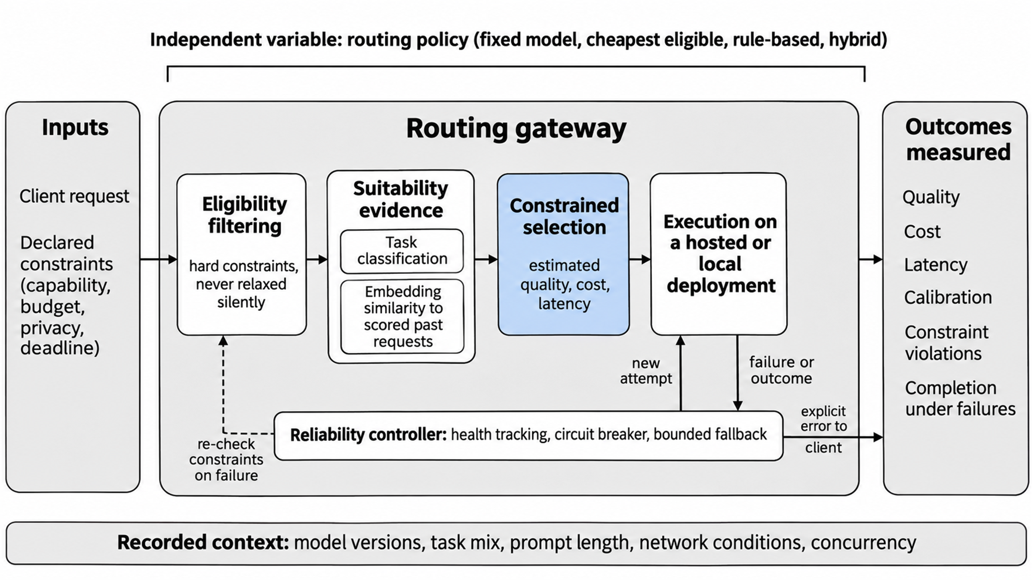
Figure 2.1: Conceptual framework of the study. Task classification and comparison with evaluated requests inform suitability; health tracking and bounded fallback operate around execution; evaluation compares quality, cost, latency, policy compliance and reliability.

2.3 Enabling Technologies and Techniques

2.3.1 Prompt classification and embeddings
Task labels give the router a coarse description of a request, and embeddings can represent its similarity to evaluated examples. CSCR and EmbedLLM use model and prompt representations in different ways (Shirkavand et al., 2025; Zhuang et al., 2025). The proposed system will test classification and embedding-derived evidence together and separately. Retrieval helps only if similar examples carry information about a candidate model’s performance and the evaluation prevents leakage.

2.3.2 Selection and budget policies
A fixed-model policy is easy to implement but cannot adapt to a prompt. A rule-based policy is interpretable, while learned predictors can estimate model-specific success but need suitable training data. FORC and Routoo connect predicted performance to cost-aware selection (Šakota et al., 2024; Mohammadshahi et al., 2024). The proposed gateway will filter candidates against hard constraints and then compare the feasible choices. Fixed-model, cheapest-eligible and rule-based policies remain evaluation baselines, and the project does not assume that they perform worse.

2.3.3 Serving performance and latency
Total latency includes gateway processing, any queueing and the time taken by the selected deployment. Etalon distinguishes delay before the first token from the timing of later tokens, while DistServe studies prefill and decoding in serving infrastructure (Agrawal et al., 2024; Zhong et al., 2024). The project will measure gateway overhead and completion time, and first-token delay where the interface allows, but it will not modify the inference engine.

2.3.4 Gateway integration, resilience and monitoring
Provider adapters will connect a common request interface to hosted APIs and local model endpoints. The gateway will apply budget rules, record decisions and use bounded fallback. A monitoring view will show request volumes, routing outcomes, estimated or recorded costs, latency, provider health and fallback events, subject to available data and privacy controls. Existing gateway and serving systems give precedents for parts of this design (LiteLLM, n.d.; OpenRouter, n.d.; Portkey, n.d.).

2.4 Review of Related Works
The 33 studies are grouped into eight themes. Table 2.3 in Section 2.6 summarises their methods, data, findings and limitations.

2.4.1 Routing algorithms
Hybrid LLM predicts the quality gap between a smaller and a larger model and routes by a threshold, reducing calls to the large model by up to 40% in its tested setting (Ding et al., 2024). It uses a limited set of model pairs and says nothing about provider failure or changing load. RouteLLM also chooses between a stronger and a weaker model, but it learns from preference data and tests transfer to other model pairs; its Table 6 reports a 3.66× cost-saving ratio against GPT-4 at 95% of GPT-4’s MT-Bench quality, a result tied to that operating point (Ong et al., 2025).
RouterDC trains query and model representations with dual contrastive objectives and reports gains of 2.76% in distribution and 1.90% out of distribution (S. Chen et al., 2024). CSCR places prompts and models in a shared embedding space, using cost-aware training and nearest-neighbour retrieval to cope with changing model pools (Shirkavand et al., 2025), and Shnitzer et al. (2023) show that benchmark correctness labels can train routers. These methods make cost–quality selection a sound starting point, but none of them shows that the combination of task classification and embedding evidence proposed here will do better. A fair test must use the same requests and candidate deployments, include a simple baseline and count the cost of the router itself.

2.4.2 Suitability prediction, difficulty and retrieval
FORC uses a small meta-model to predict the success of each language model and assigns requests under a budget, reporting about a 63% cost reduction in its setting (Šakota et al., 2024). Routoo likewise separates a performance predictor from a cost-aware selector and evaluates on MMLU (Mohammadshahi et al., 2024). Lu et al. (2024) use reward-model scores to supervise the selection of a single model before generation. Varangot-Reille et al. (2026) retrieve past performance for a few-shot router and find a simple nearest-neighbour approach competitive, with as little as 1% of history evaluated in one test.
Xiong et al. (2024) study how well language models express uncertainty and find that verbalised confidence tends to be overconfident. Their work concerns generated answers rather than a complete gateway, but it shows why a confidence score should not be treated as verified correctness without calibration. The proposed gateway will measure predictive performance and calibration on held-out data and set thresholds there.

2.4.3 Load balancing
RouteBalance combines estimated quality, latency and cost with information about available model instances (Da & Kalyvianaki, 2026). Its tests cover one model family and use offline quality labels, which limits how far the result transfers. SLOs-Serve schedules and routes work against service-level objectives across replicas (Chen et al., 2025), and GORGO estimates components of gateway latency and tunes routing weights for cross-region serving (Toniolo et al., 2026), using a single model and a synthetic trace.
These works address queueing and deadlines more directly than a quality-only router does, but each assumes a particular view of infrastructure state and uses different workloads and baselines, so their numbers are not comparable. The transferable idea is to use observable backend health and timing in eligibility and selection. Redesigning a scheduler is outside the project’s core scope.

2.4.4 Cost reduction
FrugalGPT cascades queries from cheaper to more expensive models using a learned judgement of answer quality and reports up to 98% cost reduction in its setting (L. Chen et al., 2024). Dekoninck et al. (2025) compare routing and cascading in one optimisation framework and report gains of up to 8% on RouterBench and 14% on SWE-Bench. BEST-Route chooses the model and the amount of test-time computation from predicted rewards (Ding et al., 2025). AutoMix escalates when a model’s own check of its answer is doubtful (Aggarwal et al., 2024). Gupta et al. (2024) study deferral using token-level uncertainty, which needs token probabilities that hosted providers may not expose.
A cascade must count the first generation in its cost and delay, so fewer calls to an expensive model do not automatically mean lower total cost or latency. LLM-Blender goes further and fuses several models’ answers (Jiang et al., 2023), which lies outside this project’s scope. The evaluation will count every attempt and will test single-model selection separately from operational fallback and from any optional quality cascade.

2.4.5 Latency and speed
Etalon evaluates the timing of streamed tokens against deadlines and examines both serving systems and hosted APIs (Agrawal et al., 2024). QoServe schedules requests with different quality-of-service targets on shared hardware (Goel et al., 2026), and DistServe separates prefill from decoding to improve goodput under latency targets (Zhong et al., 2024). Each mechanism addresses a different part of the request path.
QoServe and DistServe change scheduling or placement inside a serving system, so their results do not show that a gateway alone would gain the same speed. Etalon is more useful here because it shows how an external gateway can measure observed latency. The project will record routing overhead, first-token delay where available, completion time and latency-target violations.

2.4.6 Error handling and fallback
ContinuityBench evaluates whether conversational state survives a change of provider, using a history-forwarding proxy, synthetic conversations and fault injection (Pandey & Singh, 2026a). FailureAtlas classifies failures of multi-provider gateways by origin and detectability in a small catalogue of documented entries and finds that the worst are silent (Pandey & Singh, 2026b). The two preprints share authors, so they are not independent replications. ResilienceBench-Operator tests retry and circuit-breaker patterns in a Kubernetes microservice setting (Aderaldo & Mendonça, 2026); its findings need to be validated in an LLM gateway.
SpotServe reports 2.4 to 9.1 times lower P99 latency and 54% lower cost under its preemption setup (Miao et al., 2024), and DéjàVu streams the KV cache to recover from failures (Strati et al., 2024). Both operate on engine state and cannot show how a gateway should fall back between models. Together they supply scenarios to test, not proof of the gateway’s reliability. The tests will cover timeouts, rate limits and server errors, measure the added delay and completion, and verify that bounded retries keep the request’s hard constraints.

2.4.7 Testing and benchmarking
RouterBench supplies over 405,000 stored inference outcomes and a cost–quality framework for comparing routers (Hu et al., 2024). LLMRouterBench covers over 400,000 instances from 21 datasets and 33 models, with ten routing baselines and latency-aware analysis (Li et al., 2026). Both support repeatable offline comparison, but stored outputs cannot establish current provider availability or network latency. EmbedLLM is different in kind: it learns compact model representations from performance on questions and compares them with simpler alternatives (Zhuang et al., 2025); it is a candidate component to test rather than a benchmark.
The project will compare fixed, cheapest-eligible, rule-based and hybrid policies on shared prompts, candidate models, price assumptions and scoring rules, and ablation will show what the embedding component adds to task classification.

2.4.8 System design and gateway
INFaaS provides a model-less interface and selects among deployed variants for each request (Romero et al., 2021), but it was evaluated on image models. Clockwork uses predicted execution times to schedule inference predictably (Gujarati et al., 2020), without a multi-provider fallback workflow. Mélange studies the placement of LLM serving workloads across GPU types (Griggs et al., 2024), which helps motivate an explicit accounting basis for local inference. None of these alone validates the proposed gateway’s architecture, and none establishes that its combination of adapters, fallback and monitoring is new, so those functions must be built and evaluated in their own right.

2.5 Review of Existing Systems
Table 2.2 compares three existing gateway products with the proposed system, using their official documentation accessed on 31 October 2026. This is grey literature, not peer-reviewed evidence of performance. A tick means a documented feature, or a planned feature for the proposal; P means a partial or rule-based form; a question mark means the checked pages did not establish the feature, which is not evidence that it is absent. The ticks for the proposed system are planned, not implemented.
Table 2.2: Feature comparison of existing systems and the proposed system
Feature | OpenRouter | LiteLLM | Portkey | Proposed system
Per-prompt automatic model selection | ✓ | ✓ | P | ✓
Retries and fallback on execution failure | ✓ | ✓ | ✓ | ✓
Connection to local or self-hosted models | ? | ✓ | P | ✓
Hard budget and privacy limits kept during fallback | ? | ? | ? | ✓
Hybrid task and embedding suitability estimator | ? | ? | ? | ✓
Published ablations and baseline comparisons | ? | ? | ? | ✓

OpenRouter documents an Auto Router for per-prompt selection and model and provider fallback (OpenRouter, n.d.). LiteLLM documents an auto router separate from its core load balancer, with retries, cooldowns, timeouts and fallbacks, and routing across deployments (LiteLLM, n.d.). Portkey documents conditional routing policies and prioritised fallback with retry controls (Portkey, n.d.). Product features change, so they will be rechecked before submission.
The project does not claim novelty for offering one endpoint, per-prompt routing or fallback. Its contribution is the specified constrained policy, the comparison against simpler baselines and the separately evaluated recovery.

2.6 Summary of Reviewed Works
Table 2.3 summarises the 33 reviewed studies in the order of the themes in Section 2.4. Numerical findings appear only where they were checked against the abstract or text of the study.
Table 2.3: Summary of related works
S/N | Author(s) and year | Aim / problem | Method / technique | Dataset / tools | Key findings | Limitations / gap
1 | Ding et al. (2024) | Cut large-model calls while keeping quality | Router predicts the quality gap between a small and a large model; threshold | MixInstruct | Up to 40% fewer large-model calls in the tested setting | Two models; no failure or load
2 | Ong et al. (2025) | Cut cost by routing between a strong and a weak model | Router trained on human preference data | Chatbot Arena; MT-Bench, MMLU, GSM8K | 3.66× cost-saving ratio versus GPT-4 at 95% of its MT-Bench quality (Table 6) | Two-model setting; distribution shift
3 | S. Chen et al. (2024) | Match each query to a suitable model | Query and model representations with dual contrastive learning | Multi-task model outcomes | +2.76% in distribution; +1.90% out of distribution (abstract) | Small model pool; training complexity
4 | Shirkavand et al. (2025) | Cost-aware routing over changing model pools | Shared prompt–model embedding; cost-aware contrastive training; nearest-neighbour retrieval | EmbedLLM, MixInstruct, RouterBench | Reported to cope with unseen models and prompts | Static cost; no live load or failover
5 | Shnitzer et al. (2023) | Select models using benchmark results | Router learned from benchmark correctness labels | Public benchmark outcomes | Benchmark labels can train routers | Benchmark-specific labels; preprint
6 | Šakota et al. (2024) | Cheapest model that solves each query | Meta-model predicts per-model success; assignment under a budget | HELM tasks; OpenAI models | About 63% cost reduction (abstract) | Price-only cost; no latency or load
7 | Mohammadshahi et al. (2024) | Cheapest adequate model per prompt from a large pool | Correctness predictor plus cost-aware selector | MMLU | Reported accuracy gains at equal cost (figures not reused) | One benchmark; preprint
8 | Lu et al. (2024) | Select one model using reward supervision | Reward-guided router distillation | Instruction queries; reward-model scores | Rewards can supervise pre-generation choice | Depends on reward quality
9 | Varangot-Reille et al. (2026) | Generalise routing from past performance | Few-shot router with performance retrieval | Routing benchmarks | Simple nearest-neighbour is competitive; 1% history in one test | Label and retrieval setting
10 | Xiong et al. (2024) | Measure LLM confidence elicitation | Prompting, sampling and aggregation strategies | QA and reasoning datasets | Verbalised confidence tends to be overconfident | Needs a generation per query
11 | Da & Kalyvianaki (2026) | Choose model and instance jointly under load | Weighted quality–latency–cost score with load tracking | Qwen2.5 models; multi-GPU cluster | Joint choice reported faster than a quality-only router at high load | One model family; offline labels; preprint
12 | Chen et al. (2025) | Meet per-stage service targets across replicas | Token-budget scheduler; admission control; routing | vLLM; ShareGPT, HumanEval, ToolBench | Higher capacity than compared systems | Needs profiling; few replicas; preprint
13 | Toniolo et al. (2026) | Route across regions using cache, load and network latency | Latency cost model with online weight tuning | SGLang; three regions | Better tail latency than session affinity on held-out windows | Single model; synthetic trace; preprint
14 | Chen, L. et al. (2024) | Reduce API spending | Learned quality-based cascade | Scored API task outputs | Up to 98% cost reduction (arXiv abstract) | Needs labelled similar data; sequential calls
15 | Dekoninck et al. (2025) | Unify routing and cascading | Optimisation view; cascade routing with estimators | RouterBench, SWE-Bench and others | Gains of up to 8% (RouterBench) and 14% (SWE-Bench) | Estimator quality decisive; static costs
16 | Ding et al. (2025) | Route without over-using the largest model | Predict reward for (model, samples) choices | MT-Bench; eight LLMs | Reported large cost reduction for a small quality drop (figure not reused) | One judge; static prices
17 | Aggarwal et al. (2024) | Decide when to escalate a weak answer | Self-verification and POMDP-based escalation | QA benchmarks | Self-verification informs escalation | Answer-dependent; sequential inference
18 | Gupta et al. (2024) | When should a small model defer | Learned deferral on token-level uncertainty | FLAN-T5 models; NLP tasks | Learned rules more consistent than simple confidence scores | Needs token probabilities
19 | Jiang et al. (2023) | Combine models’ answers | Pairwise ranking and generative fusion | Candidate response sets | Ranking and fusion combine strengths | Many generations; out of scope here
20 | Agrawal et al. (2024) | Better latency evaluation for LLM serving | Token-deadline fluidity index; black-box API probing | vLLM, hosted APIs | Tail token timing can differ from averages | Preprint
21 | Goel et al. (2026) | Co-schedule mixed latency classes | Deadline-aware scheduling per QoS class | Llama3-8B, Qwen-7B; Azure traces | More capacity than siloed serving | Small models; own SLO classes
22 | Zhong et al. (2024) | Maximise goodput under latency targets | Prefill–decode disaggregation; placement search | OPT models; ShareGPT, HumanEval | Higher goodput than compared systems under stated targets | Needs cluster resources
23 | Pandey & Singh (2026a) | Measure continuity under provider failover | History-forwarding proxy; fault injection; LLM judge | Synthetic conversations | Continuity preserved far better than a stateless baseline | Preprint; synthetic; no streaming
24 | Pandey & Singh (2026b) | Classify gateway failure modes | Layer × detectability taxonomy; reproductions | LiteLLM, Portkey, OpenRouter issue trackers | Worst failures are silent | Five entries; preprint; no prevalence data
25 | Aderaldo & Mendonça (2026) | Evaluate retry and circuit-breaker patterns | Declarative fault scenarios on Kubernetes | Online Boutique; k6 | Maximum attempts drives success | Microservices, not LLM gateways
26 | Miao et al. (2024) | Serve LLMs on preemptible instances | Dynamic reconfiguration and migration | Cloud spot instances | 2.4–9.1× lower P99 latency; 54% cost saving | Engine-level, not model fallback
27 | Strati et al. (2024) | Fault-tolerant LLM serving | KV-cache streaming and replication | Multi-GPU serving | Faster recovery from failures | Needs engine state access
28 | Hu et al. (2024) | Standard benchmark for routers | Stored responses; cost–quality plane | Over 405,000 inference outcomes; 11 LLMs | Oracle far above any single model | No latency or load; workshop paper
29 | Li et al. (2026) | Unified current routing benchmark | Collector, evaluator, adaptor; ten routers | Over 400,000 instances; 21 datasets; 33 models | Many routers do not beat the best single model | Automated labels; public routers only
30 | Zhuang et al. (2025) | Reusable compact model embeddings | Matrix factorisation on model×question correctness | 112 open models; 10 benchmarks | Outperforms nearest-neighbour baselines | Fixed pool; correctness only
31 | Romero et al. (2021) | Model-less inference serving | Per-query variant selection; autoscaling | Image models on AWS | Lower cost and fewer SLO violations than compared systems | Image models only; no hosted APIs
32 | Gujarati et al. (2020) | Predictable tail latency | Central scheduler from predicted durations | Image models; V100 cluster | Latency targets met for very high share of requests | Deterministic models; no fault tolerance
33 | Griggs et al. (2024) | Minimise LLM serving cost across GPU types | Cost-aware bin packing over workload slices | Llama-2; L4, A10G, A100, H100 | Lower cost by workload type | Fixed workload; one model; preprint

2.7 Research Gap and Justification of the Study
The literature already contains prompt-aware selection, model-specific prediction, cost-aware routing and load-aware serving, and existing products already provide gateway functions. The gap pursued here is narrower. It is not yet established, in the setting to be tested, whether combining task classification with embedding-derived suitability justifies its overhead when hard constraints, hosted and local endpoints and bounded fallback are evaluated together against simpler baselines. Table 2.4 maps the gaps to the objectives of Chapter One. It does not assert that no existing system has any one of these features.

Table 2.4: Mapping of research gaps to project objectives
Gap identified | Evidence (studies) | Objective that addresses it
Uncertain added value of combining task classification with embedding-based per-model suitability | Ding et al. (2024); Ong et al. (2025); S. Chen et al. (2024); Shirkavand et al. (2025); Zhuang et al. (2025) | Objectives 3 and 4
Quality, cost and latency are hard to compare fairly across alternatives, and stored-outcome benchmarks omit live conditions | Dekoninck et al. (2025); Hu et al. (2024); Li et al. (2026); Agrawal et al. (2024) | Objectives 4 and 6
Hard constraints and bounded recovery are not evaluated together in one gateway | Da & Kalyvianaki (2026); Aderaldo & Mendonça (2026); Miao et al. (2024); Romero et al. (2021) | Objectives 1, 2, 5 and 6
These are project-specific questions and evidence boundaries, not claims that the literature has never studied constraints, calibration, latency or reliability. Live GPU and queue telemetry, session memory and graph-based retrieval are not part of the committed core.

2.8 Chapter Summary
The reviewed studies show several ways to predict model suitability and to trade response quality against cost. Serving and resilience studies add constraints that offline routing benchmarks cannot measure, and existing gateways already offer per-prompt routing and fallback. What remains open is whether the proposed hybrid improves on simpler policies while keeping its operational constraints in the chosen test setting. Chapter Three specifies how the gateway will be built and evaluated.

CHAPTER THREE

METHODOLOGY, SYSTEM ANALYSIS AND DESIGN
This chapter explains how the project will be carried out and how its success will be judged. It states the research design and the development model, how requirements will be gathered, the existing and proposed systems, the requirements specification and a preliminary design that includes the routing algorithm. It then sets out the data, tools and evaluation plan, with a target for every objective, followed by the ethical considerations, risks, work plan, budget and expected outcomes. Because this is a proposal, the chapter is written in the future tense and the designs are preliminary. A reader with similar skills should be able to repeat the project from this chapter alone.

3.1 Research and Development Methodology
Two separate decisions are made here: how the study will produce credible findings (the research design) and how the team will organise the building work (the development model).
Research design. The project will follow Design Science Research, because it builds an artefact, the routing gateway, to address a real problem and then evaluates the artefact against stated objectives (Hevner et al., 2004; Peffers et al., 2007). The evaluation inside it is a controlled experiment: the hybrid policy is compared with simpler policies on the same requests, candidate models and scoring rules, with hypotheses and tests set out in Section 3.9. Figure 3.1 maps the six design science activities to the project.

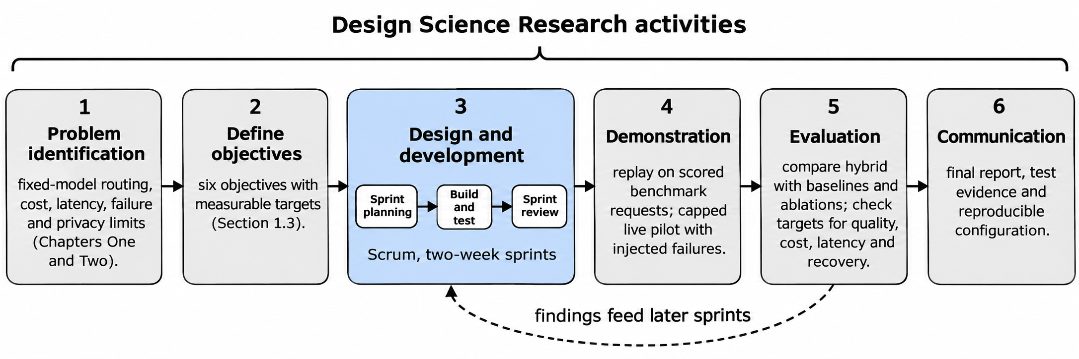
Figure 3.1: Design science activities applied to the project.

Development model. The team will use Scrum with two-week sprints. The choice follows from the project itself: the routing thresholds, features and fallback limits can be tuned only once scored benchmark data and live timing are available, so early working versions are needed and some requirements will change after the first results. The project supervisor, Dr. Emmanuel Aderemi Tunbosun, will act as product owner and approve the backlog priorities. The team leader will act as Scrum master. The sprint backlog will be kept in GitHub Projects and the code in one GitHub repository with pull-request reviews, and each sprint will end with a review of a working increment against the requirements. Each increment will keep the same external request interface, so that baseline and hybrid policies differ only in the routing mechanism and not in unrelated interface changes.
The sprints fall into five phases, planned as follows. Dates are planned, not committed, and will be reviewed with the supervisor. Section 3.12 gives the sprint plan.
• Phase 1, requirements and protocol (November to December 2026): define request policies, datasets, baseline comparisons and spending controls.
• Phase 2, baselines and gateway (December 2026 to February 2027): build request validation, the deployment registry, model adapters and the fixed-model, cheapest-eligible and rule-based policies.
• Phase 3, predictor and selector (February to March 2027): add task classification, retrieval of similar scored requests, suitability prediction and constrained selection.
• Phase 4, reliability (March to April 2027): add health tracking, circuit breakers, bounded retries and cost reconciliation, and deploy the gateway in a documented environment.
• Phase 5, evaluation and reporting (April to May 2027): run held-out replay and a capped live pilot and report the results with uncertainty. The report is due in June 2027.
Failed hypotheses, poor calibration and an infeasible model pool will be reported as findings. Changes made after the test results have been inspected will be labelled exploratory, and any confirmatory repeat will need a new untouched test set.

3.2 Requirements Elicitation
Requirements will be elicited from several sources, so that findings can be cross-checked.
• Document analysis. The project aim, the team’s recorded design decisions, the literature of Chapter Two and the documented behaviour of existing gateways (LiteLLM, n.d.; OpenRouter, n.d.; Portkey, n.d.) will show which functions such systems offer. Output: candidate requirements with a source for each.
• Inspection of benchmark data. Task and model coverage, quality labels and usage fields in RouterBench and LLMRouterBench will be examined (Hu et al., 2024; Li et al., 2026). Output: data and reproducibility requirements.
• Scenario walkthroughs and prototyping. The team will walk through a normal request, an unaffordable request, a missing capability, provider throttling, a timeout, a malformed response and partial delivery, and will sketch the request interface and the operator view. Output: observable requirements and acceptance tests.
Participants are the six team members and the supervisor, and requirements are checked by review with the supervisor in sprint reviews. The instruments are a scenario checklist and the sketches. No questionnaire or interview is planned, because human participation will be minimal or absent, and no result from a population of users will be claimed. Findings will be recorded as requirements with identifiers and MoSCoW priorities (Section 3.5) and, for the main scenarios, as acceptance criteria in the given, when and then form, which become test cases in Chapter Four. If an optional participant exercise is added later, informed consent, anonymous responses and a documented instrument will come first, and the university’s ethics process will be followed (Section 3.10).

3.3 Analysis of the Existing System

3.3.1 Description of the Existing System
In the baseline arrangement, a client application calls one predetermined LLM deployment for every request. The project will reproduce this arrangement as a fixed-model reference for comparison, without presenting it as a survey finding about how all developers work. Existing gateways already support routing and recovery in several forms (LiteLLM, n.d.; OpenRouter, n.d.; Portkey, n.d.; Section 2.5), so the comparison also includes current gateway practice.
Research comparators include pre-generation routing and cascades. Hybrid LLM uses quality-aware routing, RouteLLM learns from preference data, and FrugalGPT escalates according to the response (Ding et al., 2024; Ong et al., 2025; L. Chen et al., 2024). The study does not assume that any of these features is absent from earlier work.

3.3.2 Limitations of the Existing System
The following are design risks and comparison boundaries to be investigated, not claims that every existing product has them.
• Fixed model. There is no request-specific choice of model. Alternatives will be compared on measured quality, cost and latency.
• Quality-only selection. A high predicted score may point to an unaffordable or unavailable deployment. Hard filters and feasibility constraints will be applied first.
• Complex hybrid. Extra feature extraction may erase inference savings. Overhead and component ablations will be measured.
• Offline replay. Stored outcomes do not reproduce present network or failure behaviour. Replay will be kept separate from a capped live pilot and fault injection.
• Generic retry. Repeating a call may spend budget again or repeat side effects. Recovery will be bounded, will respect eligibility and will count every attempt.

3.4 The Proposed System

3.4.1 Description of the Proposed System
The proposed system is a gateway that gives client applications one request interface over a registered pool of hosted and local model deployments. For each request it will validate the input and filter out deployments that break mandatory constraints. It will then analyse the task and its capability needs, retrieve permitted historical evidence, predict how well each remaining model suits the request, and select the cheapest feasible candidate. Execution goes through provider adapters. A separate controller owns health state, circuit breakers, bounded attempts and outcome accounting.
A model describes a capability and a version. A deployment is a runnable endpoint with its current health, price profile and latency history. Keeping the two apart lets the evaluation distinguish model quality from deployment conditions. The users are client applications that send requests and administrators who register models, set policies and inspect behaviour. Monitoring will record selection reasons, exclusions, predicted values and observed outcomes without routinely keeping raw prompts.

3.4.2 Justification for the Proposed System
Each design choice below answers a limitation in Section 3.3.2 or a gap in Chapter Two.
• Deterministic filtering before selection. Hard restrictions are never traded away for predicted quality (Objectives 1 and 4).
• Lightweight classification with retrieval features. Each component can be tested on its own and is practical on limited compute (Objective 3).
• Cheapest-feasible selection. Cost is minimised inside declared quality and deadline constraints (Objective 4).
• A separate reliability controller. Execution failures are kept distinct from inadequate completed answers (Objective 5).
• Common adapters and versioned logs. Baselines and the hybrid share execution and measurement conventions (Objectives 2 and 6).
• Replay plus a capped live pilot. Reusing scored outputs saves API cost, while live tests measure operational behaviour (Objective 6).
The system will be built as one modular application at first. This is a provisional engineering choice that keeps the first version small, and it does not rule out adding separate services or other tools later.

3.5 Requirements Specification

3.5.1 Functional Requirements
Table 3.1 lists the functional requirements with identifiers and MoSCoW priorities (Must, Should, Could, Won’t). The identifiers are reused in the test cases of Chapter Four and Appendix D.
Table 3.1: Functional requirements
ID | Requirement | Actor | Priority
FR-01 | The gateway shall expose an OpenAI-compatible request and response interface with explicit errors. | Client application | Must
FR-02 | The gateway shall authenticate clients and validate payload, endpoint and request limits. | Client application | Must
FR-03 | The administrator shall register model versions, capabilities, context windows and authorised deployments. | Administrator | Must
FR-04 | The filter shall exclude unsupported capabilities, excessive context, privacy-policy violations, unavailable deployments and unaffordable attempts. | Client application | Must
FR-05 | The analyser shall classify the task and capability requirements before dispatch. | Client application | Must
FR-06 | The feature pipeline shall retrieve permitted historical neighbours and support an embeddings-disabled ablation. | Administrator | Should
FR-07 | The predictor shall estimate model-specific suitability and expose cases with insufficient evidence. | Client application | Must
FR-08 | The selector shall apply predicted quality, cost and deadline constraints and choose the cheapest feasible candidate. | Client application | Must
FR-09 | The gateway shall return an explicit infeasibility outcome when no permitted candidate remains. | Client application | Must
FR-10 | The accountant shall reserve permitted spend before each attempt and reconcile known or uncertain usage without releasing uncertain charges early. | Administrator | Must
FR-11 | Adapters shall support one hosted API and at least one local engine. | Provider / model backend | Must
FR-12 | The controller shall track deployment health and closed, open and half-open circuit-breaker states. | Administrator | Must
FR-13 | The controller shall perform bounded fallback only for eligible retryable failures, rechecking budget, deadline and hard filters. | Provider / model backend | Must
FR-14 | Recovery shall not splice streams across models or repeat side effects whose safe retry is unknown. | Client application | Must
FR-15 | Monitoring shall record decisions, attempts, usage and timing while minimising sensitive content. | Administrator | Must
FR-16 | The evaluator shall run shared baselines, component ablations, calibration and fault tests with versioned configurations. | Administrator | Must
FR-17 | A monitoring view or export shall show aggregate quality, cost, latency, health and constraint outcomes. | Administrator | Should
FR-18 | The gateway shall be deployed in a documented environment, with configuration and installation instructions, accessible to authorised testers. | Administrator | Must
FR-19 | A separately labelled quality-cascade experiment may escalate completed but inadequate responses. | Administrator | Could
FR-20 | Reinforcement learning and response fusion shall be excluded from the first version. | Administrator | Won’t

3.5.2 Non-Functional Requirements
Table 3.2 states each quality requirement with a measure and a target. Targets are fixed now, before any results exist, and may be revised after a pilot only with a recorded reason and before the test results are examined. No target allows a hard restriction to be ignored.
Table 3.2: Non-functional requirements
ID | Category | Requirement | Measure and target
NFR-01 | Quality | Preserve quality relative to the best single model chosen on validation data. | Hybrid quality within 2 percentage points of the best single model; lower limit of a one-sided 95% interval above −2 points.
NFR-02 | Efficiency | Reduce inference spending without hiding router and retry costs. | At least 20% lower cost per completed request than the best-single-model reference.
NFR-03 | Efficiency | Keep gateway overhead small. | p95 gateway overhead (routing and selection, excluding model generation) of at most 100 ms on paired direct and gateway calls.
NFR-04 | Reliability | Complete eligible requests under injected failures. | At least 95% of eligible requests completed under each injected failure type.
NFR-05 | Correctness | Preserve constraints and account for concurrent attempts. | Zero unreported hard-constraint violations; all concurrency and reservation assertions pass.
NFR-06 | Calibration | Quantify how reliable the confidence estimates are. | Brier score below that of a constant-probability predictor on held-out requests.
NFR-07 | Security and privacy | Restrict access and avoid logging sensitive prompts or keys. | All negative authentication, endpoint-policy and redaction tests pass; no secret found in sampled logs.
NFR-08 | Maintainability | Trace requirements to repeatable tests. | 100% of Must requirements traced to at least one test; at least 70% line coverage of the selector and execution controller.
NFR-09 | Reproducibility | Reproduce reports from versioned inputs and configuration. | An independent rerun reproduces quality within 1 percentage point and cost within 5%.
NFR-10 | Usability and accessibility | Make operator errors and status understandable. | Keyboard navigation, labelled controls and plain-language errors confirmed on every operator screen by scenario walkthrough.

3.5.3 Use Case Model
Figure 3.2 shows the actors and use cases. The client application provides the request and policy, the administrator configures and inspects routing, and the provider or model backend executes model calls. Calibration uses permitted validation evidence rather than uncontrolled updates from test outcomes.
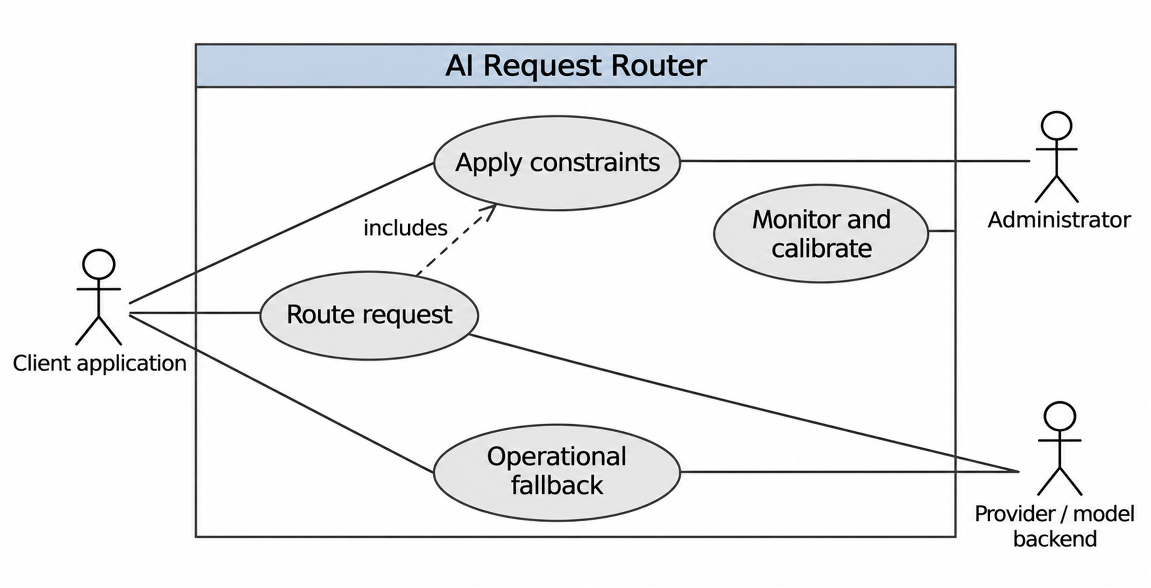
Figure 3.2: Use cases and external actors.
Table 3.3 describes the three most important use cases.
Table 3.3: Use case descriptions
Item | UC1: Route a request | UC2: Handle an infeasible request | UC3: Operational fallback
Actor | Client application | Client application | Provider / model backend; reliability controller
Preconditions | Client is authenticated; models and policy are registered. | Request is valid but declared constraints cannot all be met. | An attempt has been dispatched and has failed.
Main flow | 1. Client sends request and policy. 2. Gateway filters, classifies and predicts. 3. Selector chooses the cheapest feasible deployment. 4. Spend is reserved and the request executes. 5. Usage is reconciled and the response is returned. | 1. Filters leave no eligible candidate, or none is feasible. 2. Gateway rejects with an explicit infeasibility error. 3. Event is recorded without raw prompt text. | 1. Failure is recorded and breaker state updated. 2. Uncertain spend is reconciled. 3. Constraints and remaining budget and deadline are rechecked. 4. A new permitted attempt is made.
Alternative flows | Reservation fails: budget error before dispatch. Caller cancels: no further attempts. | Soft preference may later be relaxed under an explicit policy. | Retry unsafe, attempts used up or no feasible candidate: explicit failure with no relaxation of hard constraints.
Postconditions | Decision, attempt and cost recorded; response or error returned. | No model called; client informed why. | Attempts bounded; outcome and extra cost recorded.

3.6 System Design
The designs in this section are preliminary. They show the architecture, use cases, data model, interface and algorithm, and they will be completed, with a data dictionary and full diagrams, in the final report.

3.6.1 System Architecture
The gateway will be one application made of logical modules rather than separate services. Preprocessing validates the declared requirements and classifies the task and capability needs. The retrieval path uses embeddings and a k-nearest-neighbour (k-NN) index built only from permitted historical records. The suitability predictor estimates quality, the selector assesses feasibility and ranks candidates, and the execution controller owns attempts and recovery. A modular layout keeps the first version simple and lets each component be switched off for ablation tests.

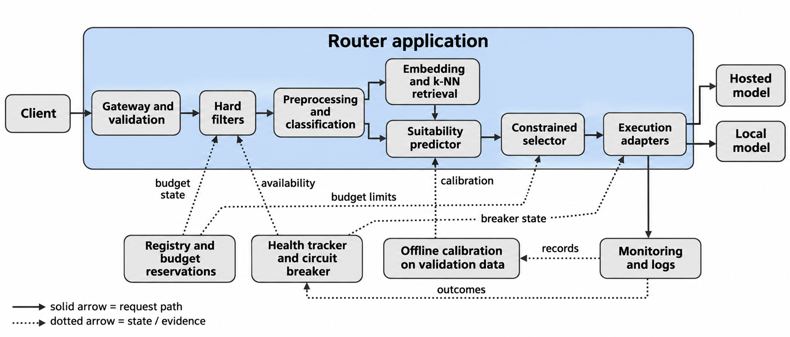
Figure 3.3: Logical architecture of the router. Solid arrows show the request path; dotted arrows show evidence and state dependencies.

Figure 3.4 shows the planned development and evaluation deployment on the two laptops. The allocation is provisional until the machines are profiled; it does not assume that models are loaded at the same time or that the two laptops have equal graphics memory. Memory contention between embeddings and local inference will be measured.

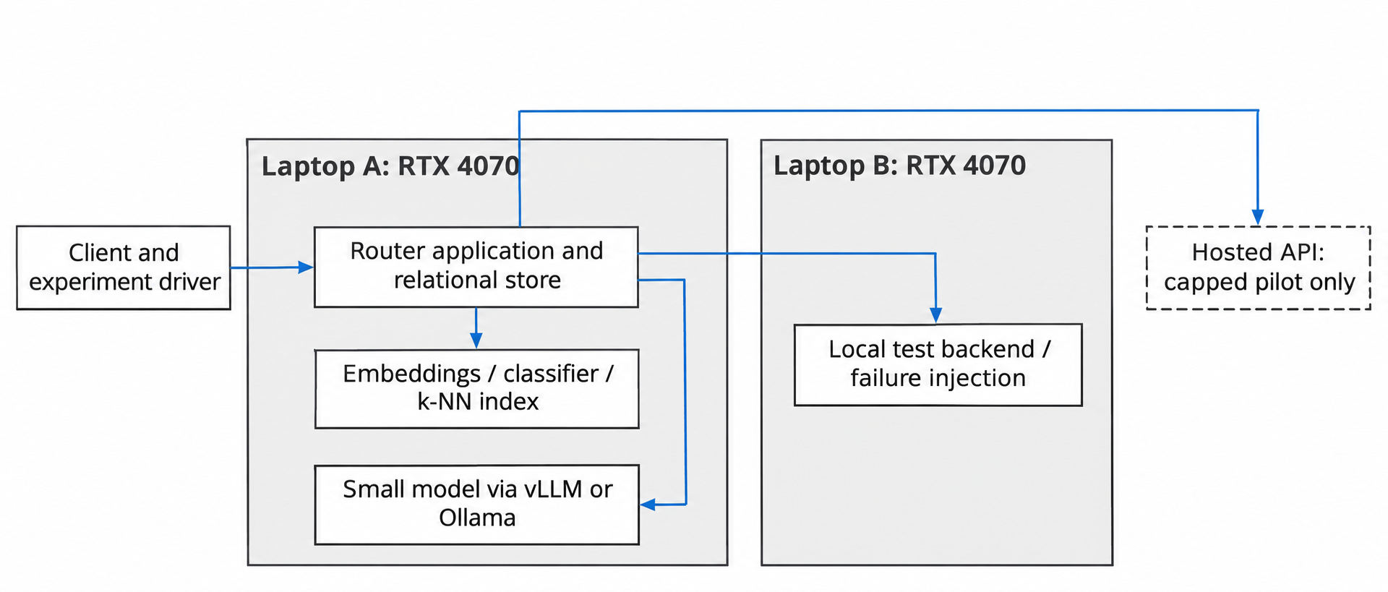
Figure 3.4: Proposed development and evaluation deployment.

3.6.2 Structural Design (Class Diagram)
Figure 3.5 shows the main classes and their responsibilities. The selector does not call providers or change health state. The execution controller rechecks policy and reserves budget before every attempt. The adapter translates protocol differences and returns explicit usage and error information. Keeping these responsibilities apart supports ablations without duplicating recovery rules.
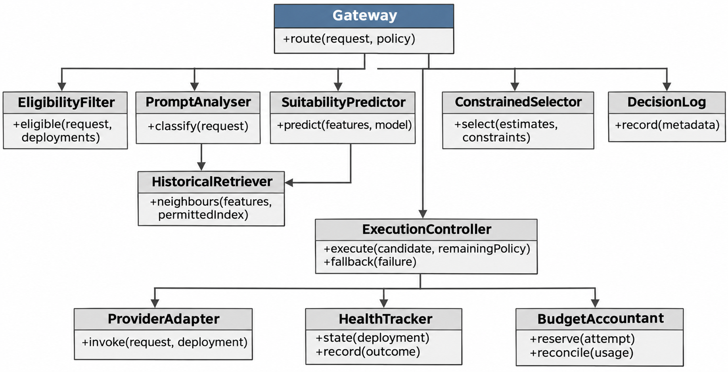
Figure 3.5: Proposed classes and responsibilities.

3.6.3 Behavioural Design (Sequence and Activity Diagrams)
Figure 3.6 shows a normal request. Validation, filtering and budget reservation come before execution.
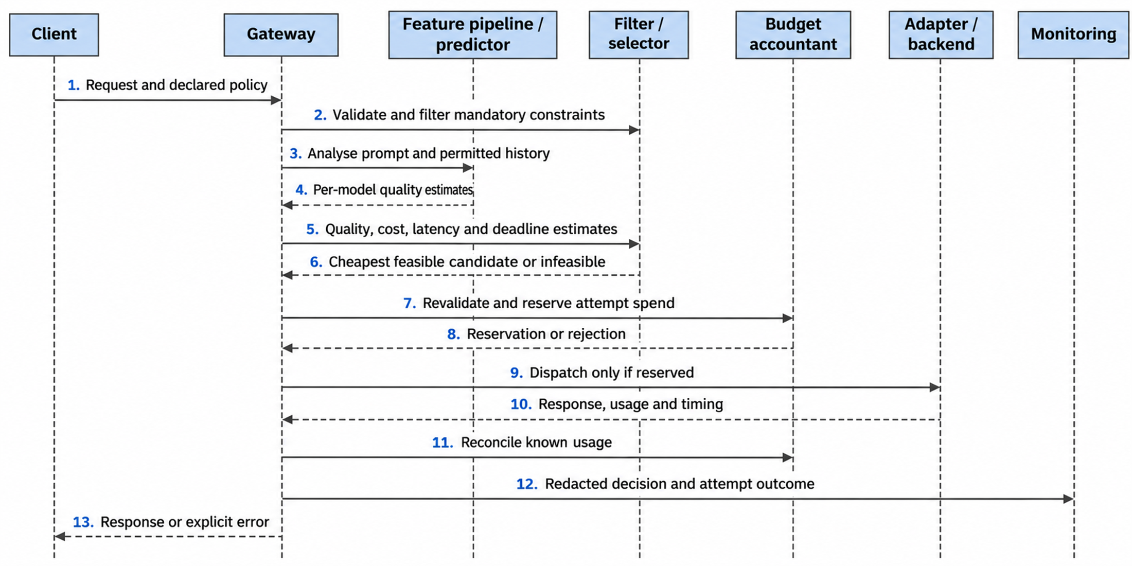
Figure 3.6: Sequence diagram of a normal routing request.
Figure 3.7 shows an execution failure and fallback. Recovery is a new constrained attempt, not the continuation of a stream that has already been delivered.
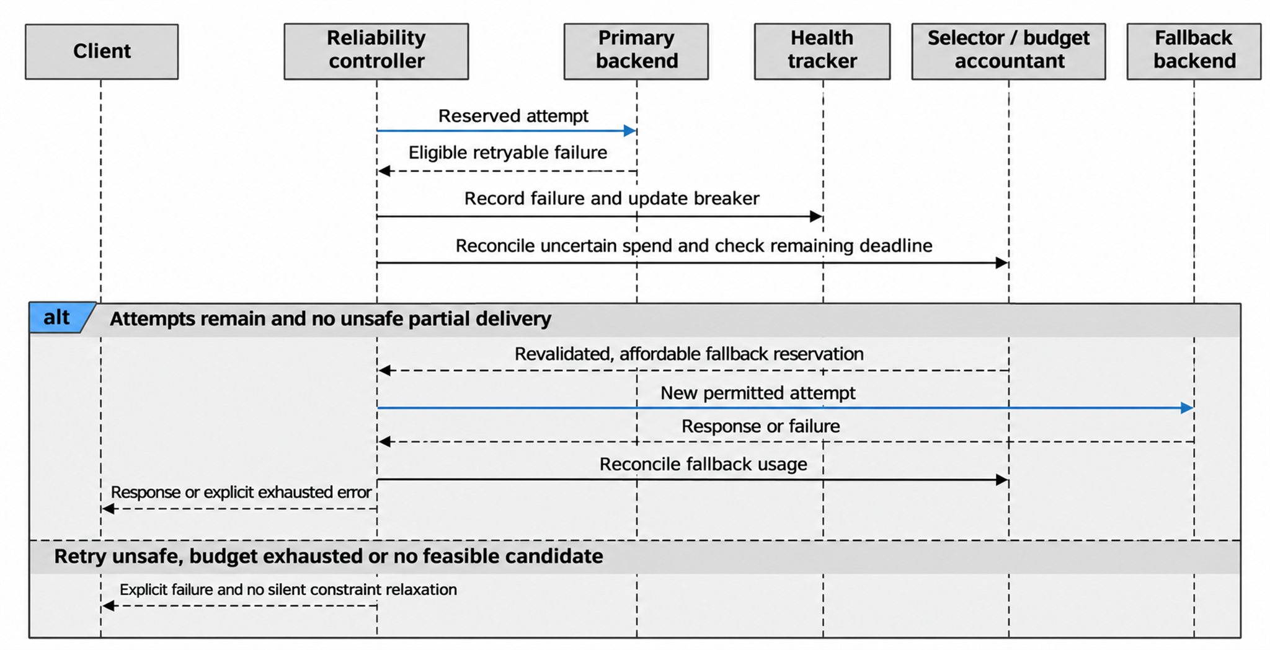
Figure 3.7: Sequence diagram of an execution failure and operational fallback.

Figure 3.8 shows the request activity flow. Infeasibility, where no permitted candidate exists, is distinguished from a provider failure. A failed reservation or a change in health state causes revalidation or an explicit error before dispatch. Every pass through the recovery loop uses up an attempt allowance, so retries cannot continue without limit, and cancellation by the caller ends further attempts.
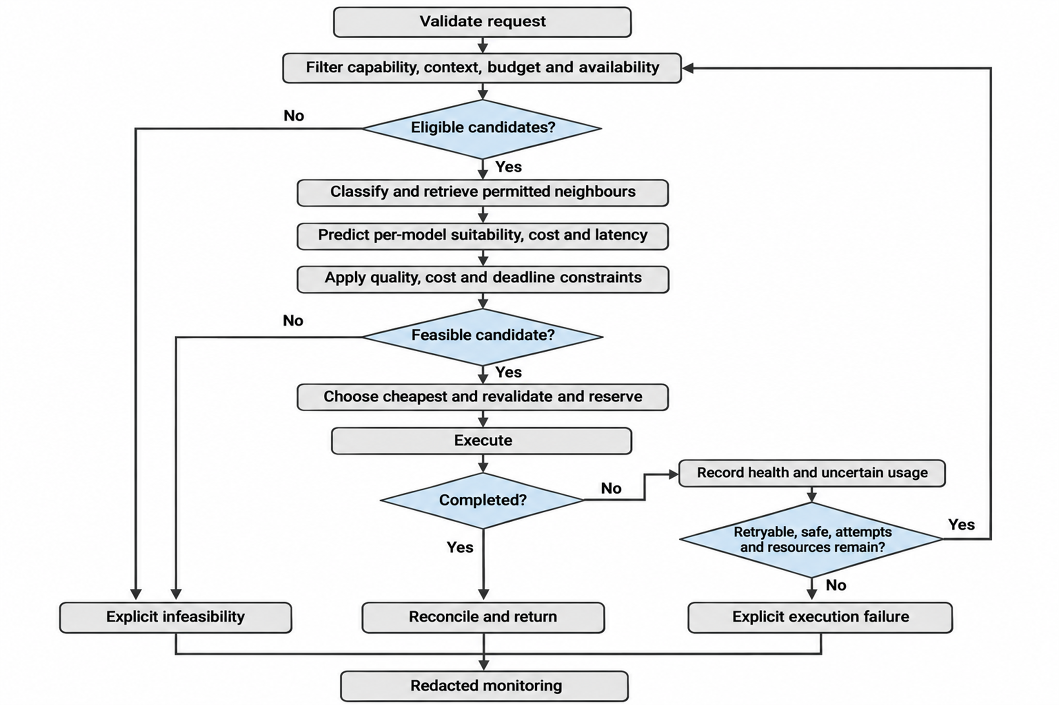
Figure 3.8: Activity flow of a request.

3.6.4 Database Design
The relational schema will keep stable model metadata apart from deployments and attempt records. Capabilities are held in a join table rather than a comma-separated field. A versioned price record preserves the rate used for accounting, so current prices never overwrite historical costs. Raw prompt text is not required in the operational request table. Figure 3.9 shows the entities and Table 3.4 gives the relations in third normal form (3NF).
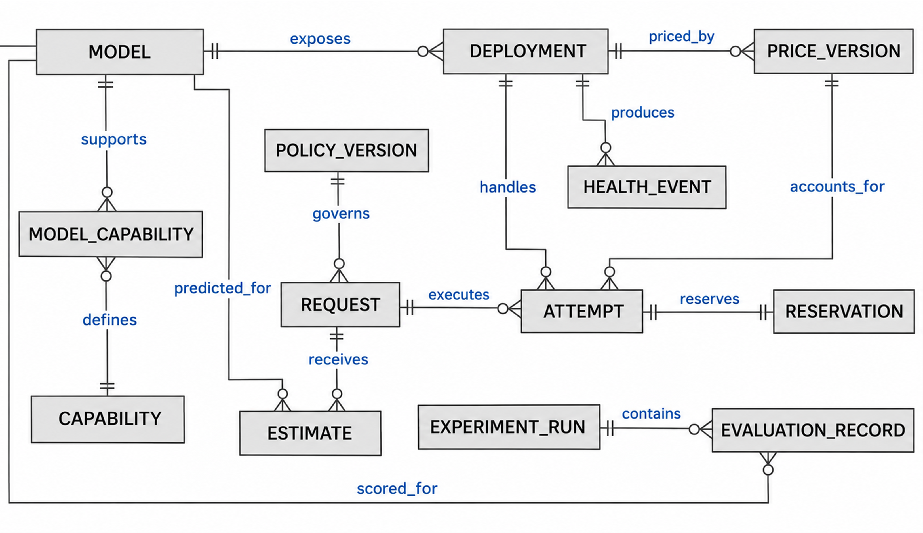
Figure 3.9: Entity relationship diagram.

Table 3.4: Relational schema in third normal form
Relation | Primary key | Other attributes and foreign keys | Normalisation rationale
Model | model_id | revision, context_limit, tokenizer_ref | Model ID determines one pinned model definition.
Capability | capability_id | capability_name | One capability name per ID.
ModelCapability | model_id, capability_id | Both foreign keys | Composite key records each supported capability once.
Deployment | deployment_id | model_id (FK), authorised_endpoint_ref, engine | Endpoint metadata depends on the deployment, not the request.
PriceVersion | price_id | deployment_id (FK), effective_at, input_rate, output_rate, currency, cost_basis | Immutable price ID fixes the historical rate.
PolicyVersion | policy_id | quality_floor, cost_cap, deadline_rule, policy_revision | A frozen policy version determines its parameters.
Request | request_id | policy_id (FK), accepted_at, token_estimate, final_status | Request-specific facts only.
Estimate | request_id, model_id | quality_estimate, cost_estimate, latency_estimate, predictor_revision | One frozen prediction per candidate for each request.
Attempt | attempt_id | request_id (FK), deployment_id (FK), price_id (FK), ordinal, start_at, end_at, outcome, usage_state, known_cost | Attempt-specific execution facts; request and ordinal are unique.
Reservation | attempt_id (PK, FK) | reserved_amount, reconciliation_state | At most one reservation per dispatched attempt.
HealthEvent | event_id | deployment_id (FK), observed_at, signal, breaker_transition | Each health event is kept on its own.
ExperimentRun | run_id | dataset_revision, split_manifest_ref, configuration_ref, seed_ref | Run-level provenance is not repeated across scores.
EvaluationRecord | run_id, task_key, model_id | score, token_counts, cost_basis_ref | Outcome keyed by run, task and model.

Each relation has atomic fields and attributes that depend on the whole key, and facts about other entities are held in their own relations; this is the proposed 3NF rationale and will be reviewed when the schema is implemented. Currency values will use fixed-precision decimals with explicit units to avoid rounding drift in the ledger. Concurrent reservations will be transactional, and unknown usage after a timeout stays reserved until resolved or conservatively charged. Secrets are held in a protected store and are not stored in these tables.

3.6.5 Algorithm and Model Design
For a request q and a candidate model m, the predictor will estimate suitability as a function of task, difficulty, similarity and model:
Q̂(m, q) = f(task, difficulty, similarity, model)
Classification is lightweight. Mandatory request fields are filtered first, and any capability requirement found during analysis is applied again before selection. The classifier never weakens an explicit client restriction. Difficulty and similarity are predictive features, not independent proof of quality, and similarity features come only from permitted historical outcomes. A score will not be called a probability unless its label definition and calibration justify that.
Let E(q) be the deployments that pass capability, context, privacy, health and preliminary affordability rules, B_rem the remaining permitted budget, D_rem the remaining deadline and τ the minimum predicted quality. The feasible set is:
F(q) = { m ∈ E(q) : Q̂(m, q) ≥ τ, Ĉ(m, q) ≤ B_rem, L̂(m, q) ≤ D_rem }
The selected deployment minimises expected cost among the feasible candidates:
m* = argmin over m ∈ F(q) of Ĉ(m, q)
Predicted latency breaks ties, followed by a stable deployment identifier so that runs can be reproduced. Predicted feasibility does not guarantee observed quality or latency, so those violations are measured. Before execution, a conservative reservation based on input and output caps supplements the expected-cost ranking. If chargeable tokens cannot be bounded, a hard budget requires a conservative bound or rejection.
A weighted utility will be evaluated only as a comparator:
U(m, q) = α·Q̂(m, q) − β·C̃(m, q) − γ·L̃(m, q)
The tildes mean normalised cost and latency; scaling constants and weights are chosen on validation data only. The comparator still obeys the hard restrictions, because cheap inference cannot make up for an unsupported capability or unauthorised spend. The routing procedure is:
ROUTE(q, policy):
validate client, payload, authorised endpoints and declared constraints
initialise finite attempt allowance, deadline and request accounting
while allowance remains and caller has not cancelled:
E <- filter capability, context, privacy, health and budget rules
features <- classify q; retrieve only permitted historical evidence
E <- re-apply capability filters using the analysed requirements
estimates <- predict quality, cost and latency for E
F <- enforce quality floor, cost cap and remaining deadline
if F is empty: return explicit INFEASIBLE under the declared policy
candidate <- cheapest feasible candidate (deterministic tie break)
atomically revalidate and reserve conservative attempt spend
if reservation fails: return explicit budget or state error
consume one attempt allowance
outcome <- execute with remaining timeout through the adapter
reconcile known usage; keep reservation for unresolved charges
record redacted estimates, timing, exclusions and health outcome
if completed: return response
if not retryable, unsafe to repeat or partial output sent: return error
return explicit EXHAUSTED or CANCELLED outcome

When no candidate is feasible, the first version will reject the request with an explicit error. Later versions may relax an explicitly soft preference or ask the caller for permission to exceed a constraint, but no path will silently relax a hard budget, capability or privacy rule. Retry eligibility, attempt count, cooldown and circuit-breaker thresholds will be set after the pilot. After delivery has begun, the gateway reports failure instead of joining another model’s stream to the first, and calls with unsafe or uncertain side effects are not repeated automatically.
Monitoring feeds an offline calibration process; logging alone is not described as online adaptation. Quality-based cascading remains a separate optional experiment after completed responses, and its verifier calls, cost and latency are counted separately.

3.6.6 User Interface Design
The client-facing interface is the request API. It returns a response or an explicit validation, infeasibility, budget or execution error, with a correlation identifier. Client applications do not need to know how the predictor works to submit a request. The administrator interface prioritises observation and safe configuration: it shows the active model pool, deployment health and circuit-breaker state, reserved spend, aggregate quality and calibration, and latency. By default it does not show raw prompts or credentials, and configuration changes need administrator rights and leave a versioned record. Figure 3.10 is the planned layout.
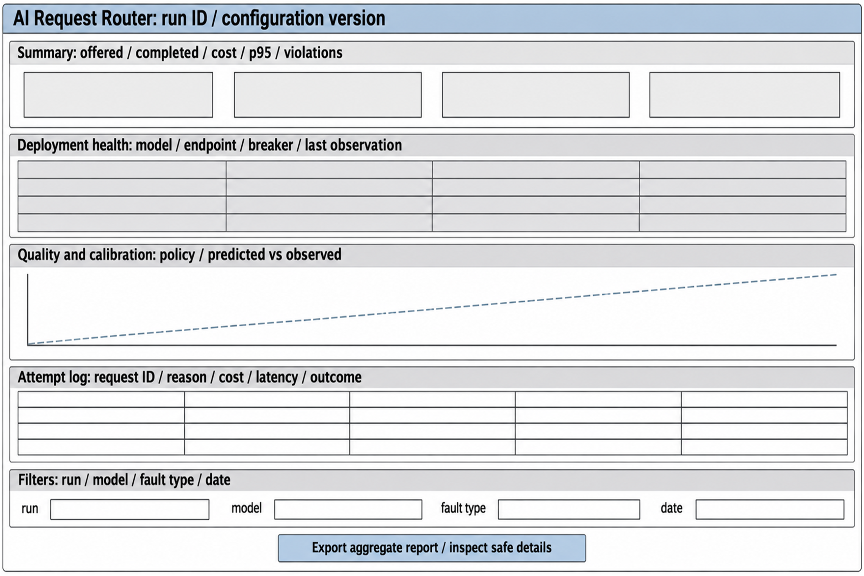
Figure 3.10: Proposed operator dashboard wireframe.

Labels and errors will be readable without relying on colour alone. Controls will support keyboard navigation, visible focus, descriptive labels and a clear empty and error state, and measured values will show units and sample counts. A read-only export may be built before a fuller dashboard, which matches the Should priority of requirement FR-17.

3.6.7 Security and Privacy Design
The gateway will authenticate callers, separate administrator permissions and validate payload size, context and output caps and authorised endpoints. Deployment addresses are controlled by the administrator, and protections against server-side request forgery check schemes, destinations and redirects while allowing only explicitly authorised local endpoints. Provider credentials stay out of client responses, model prompts and routine logs. Input text is treated as untrusted data: instructions inside a request cannot change permissions, budget accounting, secret access or retry policy. Calls with side effects need an explicit safe-retry contract, because a transport failure does not show that an earlier action did not happen.
The project will keep the data it retains to a minimum, use anonymous request identifiers and prefer aggregate records. Raw personal or confidential data will not be collected on purpose or sent to hosted models, and logs and exports will be redacted. The Nigeria Data Protection Act, 2023 is considered in the design. Its principles of personal data processing (section 24) include lawful processing, purpose limitation, data minimisation and storage limitation, and sections 41 to 43 govern transfers of personal data out of Nigeria (Federal Republic of Nigeria, 2023). These are regulatory requirements, not a claim that compliance has been achieved. If personal data is ever processed, the team will document its lawful basis, notices, access and deletion process, recipient restrictions and any cross-border arrangement before collection, and will not infer these merely from a provider offering an API.
Security tests will include unauthenticated calls, privilege violations, forbidden endpoints, oversized inputs, secret and redaction checks, and fallback attempts that would break privacy or budget policy. The absence of formal ethics approval does not replace privacy or security obligations.

3.6.8 Traceability of Requirements to Design and Tests
Table 3.5 begins the traceability matrix, linking requirements to the design elements that satisfy them and to the kind of test that will check them. Test identifiers will be assigned when the test plan is written, and the matrix will be completed in the final report.
Table 3.5: Draft traceability of requirements to design and tests
Requirement | Design element | Planned test
FR-01, FR-02 | Gateway and validation (Figure 3.3) | API contract and authentication tests
FR-03 | Registry; Model and Deployment relations (Table 3.4) | Registry and constraint tests
FR-04, FR-09 | Eligibility filter; infeasibility branch (Figure 3.8) | Filter unit tests; infeasible-request cases
FR-05 to FR-08 | Prompt analyser, retriever, predictor, selector (Figure 3.5; Section 3.6.5) | Held-out ablation and selection tests
FR-10 | Budget accountant; Reservation relation (Table 3.4) | Concurrent-reservation assertions
FR-11 to FR-14 | Provider adapter, health tracker, execution controller (Figures 3.5 and 3.7) | Fault-injection tests
FR-15 to FR-17 | Decision log; operator view (Figure 3.10) | Redaction and export tests
FR-18 | Deployment (Figure 3.4) | Deployment checklist run by a second member
NFR-01 to NFR-03 | Selector; evaluation pipeline (Figure 3.11) | Quality, cost and overhead evaluation
NFR-04, NFR-05 | Reliability controller; budget accountant | Failure-injection and violation tests

3.7 Data Collection and Preparation
RouterBench and LLMRouterBench are the candidate sources of already-scored model outputs (Hu et al., 2024; Li et al., 2026). The team will inspect task identifiers, prompts, model revisions, scores, token counts and cost fields before choosing a shared evaluation subset. The evaluated pool will contain three to four models covering a small local option, a mid-tier option and a frontier option. Names will be fixed once aligned scored outputs for the same requests are confirmed, because a model’s public availability in a benchmark does not by itself show that its outcomes line up with the others. Table 3.6 lists the planned controls.
Table 3.6: Data preparation controls
Data stage | Planned control
Provenance | Record the official release, revision, file hashes, model IDs, prompting settings and label definitions.
Coverage | Verify aligned per-request outcomes for the chosen models, spanning a small, a mid-tier and a frontier option.
Licence | Check dataset and component terms separately from code licences (Appendix G).
Cleaning | Detect duplicate and near-duplicate prompts, invalid scores, missing outcomes and inconsistent token or cost units.
Split | Group related requests and keep duplicates in one partition; training, validation and test partitions fixed before tuning.
Features | Fit classification, the retrieval index, normalisers and calibration only on training and validation partitions.
Evaluation | Keep evaluated outcomes out of training and retrieval for those requests; reveal labels only for scoring.

A benchmark’s own split will not automatically become the study protocol. A tuning pilot will be kept separate from the untouched test partition. If aligned outcomes across models are not available, the limitation will be recorded rather than filled with unrelated benchmark averages. No raw benchmark data will be redistributed with the report. RouterBench has an MIT code licence, but the inspected data card did not establish a dataset-level redistribution grant, and the MIT badge on LLMRouterBench does not settle its missing data licence text; dataset use will be cleared in Appendix G before data is used. New hosted calls will be limited to a capped pilot, with the provider and amount recorded before the pilot starts. A quantised local model and a historical hosted version of a similarly named model are separate configurations and are not assumed to share quality labels.

3.8 Tools and Technologies
Table 3.7 lists the planned tools and the reason for each. Versions will be fixed and listed in the environment manifest.
Table 3.7: Tools and technologies
Tool or technology | Purpose | Justification
Python and FastAPI | Gateway and common API | Asynchronous request handling and automatic input validation; same language as the machine-learning tools.
Python ML Frameworks like sentence-transformers and scikit-learn | Embeddings, classification and prediction | Lightweight and practical on laptop hardware; exact models chosen after testing.
k-NN index | Retrieval of similar scored requests | Simple, testable and supports the embeddings-off ablation; index type and k chosen on validation data.
Ollama | Local model serving | Straightforward on Windows laptops; vLLM can be tried if memory allows.
Provider APIs (capped) | Hosted model access | Small capped pilot only; provider and amount recorded before use.
PostgreSQL | Registry, attempts, accounting and experiment provenance | Transactions for concurrent budget reservations; relational integrity.
pytest and a fault-injection harness | Unit, integration and failure tests | Requirement-traceable tests; controlled injection of failures on local backends.
Git and GitHub | Version control | Versioned configurations and reproducible experiments.
Two RTX 4070 8gb laptops (Lenovo Legion 7i, ASUS ROG Zephyrus G16) | Feature extraction, classifier, index and small local inference | Available to the team; memory and throughput will be measured separately.
GitHub Projects | Sprint backlog and tracking | Free for students; keeps backlog next to the code.
AI image generation (ChatGPT image mode;s) | Drawing the figures of this chapter from the team’s own written design descriptions | Speeds up diagram production; each figure was checked against its description and the use is declared in Appendix H.

Tools such as Redis and Prometheus, and direct live collection of graphics-card and queue data, are not part of the committed core and could be added later only after a separate scope decision. The final environment record will state operating systems, driver and runtime versions and package versions instead of calling a changing “latest” release reproducible.

3.9 Evaluation Plan
The evaluation answers the research questions of Section 1.4. Its primary comparison asks whether the hybrid keeps quality within a justified non-inferiority margin of the best single model chosen on validation data, while reducing cost and latency. The primary score and margin will be chosen and justified before the test outcomes are seen, and non-inferiority will not be inferred from a non-significant test of superiority. Table 3.8 defines the arms.
Table 3.8: Evaluation arms
Arm | Definition
Fixed model | Route all comparable requests to each candidate in turn; the single-model reference is chosen on validation evidence only.
Cheapest eligible | Select the least expensive deployment after the shared hard filters, without learned suitability.
Rule-based task routing | A deterministic task-to-model rule defined from training evidence.
Lightweight learned predictor | Predict suitability from the chosen lightweight features, without historical retrieval.
Hybrid | Task classification and embedding-derived suitability features with constrained selection.
Component ablations | Remove embeddings; remove task and difficulty features; optionally retrieval-only suitability, all on identical splits.
Utility variant | Normalised weighted utility with the same hard restrictions; weights tuned on validation data only.
Optional cascade | Escalate completed inadequate answers; generation and verifier calls charged separately.

Ablations change only the named component. All policies share the eligible candidates, request caps, adapters and accounting. An ablation with too little data will be labelled incomplete and will not be replaced by a different task set. Table 3.9 defines the metrics.
Table 3.9: Evaluation metrics
Metric | Definition and reporting
Quality | Dataset-appropriate success or score on matched requests; per domain and in aggregate with declared weights.
Cost | Known spend plus router, verifier and retry costs on a declared basis, per offered and per successful request, with unresolved charges; local cost is not silently set to zero.
Latency | Router decision time, time to first token, end-to-end completion time, p50 and p95, including failures and deadlines.
Constraint violations | Count and rate by capability, context, budget, privacy and deadline; predicted feasibility is separated from actual violations.
Calibration | Reliability table and Brier score for binary success; a declared measure for continuous scores.
Fallback | Completed divided by eligible offered requests under each injected failure, with attempts and extra cost and latency.
Software evidence | Requirement coverage, unit and integration results, reproducible configuration and concurrency-accounting assertions.

Table 3.10 sets out, for each objective, the method, the metric, the target and the baseline. It is the contract for Chapter Four: the targets are decided now, before any results exist, and every comparison has a baseline.
Table 3.10: Evaluation plan by objective
Objective | Method | Metric | Target | Baseline
1. Requirements | Requirements-to-test matrix reviewed with the supervisor | Share of Must requirements traced to a test | 100% | Not applicable
2. Gateway | Unit, integration and API tests; deployment run by a second member | Tests passed; line coverage of core modules | All Must tests pass; at least 70% coverage | Not applicable
3. Predictor (RQ3) | Ablation on held-out scored requests | Brier score; change when embeddings or task features are removed | Brier below a constant predictor; each component’s effect reported with an interval | Constant predictor; predictor without embeddings
4. Selector (RQ4) | Replay of all arms on held-out requests | Quality; cost per completed request | Quality within 2 points of the best single model; cost at least 20% lower | Best single model; cheapest eligible; rule-based; lightweight learned
5. Reliability (RQ5) | Local fault injection: timeouts, throttling, server errors, malformed responses, interrupted streams | Completion of eligible requests; constraint violations; extra cost and latency | At least 95% completed; zero unreported violations | Single attempt with no fallback
6. Deployment and overhead (RQ6) | Paired direct and gateway calls at set concurrency; capped live pilot; independent rerun | p95 gateway overhead; reproducibility | At most 100 ms; rerun within 1 point of quality and 5% of cost | Direct call to the same deployment

Testing strategy. Unit tests will check filtering, classification, estimation, selection and accounting. Integration tests will cover adapters, the database and the request path. System tests will run the deployed gateway under concurrent load and injected failures. Acceptance tests will check each requirement identifier against the traceability matrix in Appendix D. Local fault cases will include connection errors, throttling, slow responses, malformed responses and interrupted streams. No user-acceptance study is planned; the operator interface will be checked by scenario walkthroughs, and any such result will not be presented as a population usability finding.
Replay and live measurement. Offline replay uses stored outcomes to estimate the quality and cost trade-off and the predictor’s overhead, and it does not supply current provider latency. The capped live study will compare direct and gateway calls with matched payloads, warm and cold conditions, and recorded concurrency and network context. Operational recovery is reported separately from quality escalation after a completed answer.
Hypotheses. Let ΔQ be hybrid quality minus reference quality, and let δ be the non-inferiority margin, set at 2 percentage points. The quality hypotheses are H0: ΔQ ≤ −δ against H1: ΔQ > −δ. The cost hypotheses are H0: cost per completed request is less than 20% below the reference against H1: it is at least 20% below. The overhead hypotheses are H0: p95 gateway overhead exceeds 100 ms against H1: it is at most 100 ms. These targets are fixed now. The interval level, the primary latency measure, sample sizes and stopping rules will be fixed after the pilot and before the test results are analysed. These are plans, not claims of achieved statistical power.
Statistical tests. The same requests are scored under every arm, so the comparisons are paired. Quality non-inferiority will use a paired bootstrap interval for ΔQ that resamples groups of related requests. Paired yes-or-no outcomes, such as whether a request completed, will use McNemar’s test. Paired numeric differences in cost and latency, which are unlikely to be normally distributed, will use the Wilcoxon signed-rank test. Multiple comparisons will be adjusted with the Holm method, and every result will be reported with its interval and sample count.
Paired differences will use identical requests where possible, and uncertainty intervals will resample groups of related requests rather than treat correlated copies as independent. Timeouts and rejected requests stay in the denominators of offered requests. Results will be shown per domain as well as in aggregate. Failed, inconclusive and negative results will be kept, and any retuning after test inspection will be labelled exploratory. Appendix I will hold the fixed analysis plan. Figure 3.11 shows the pipeline.
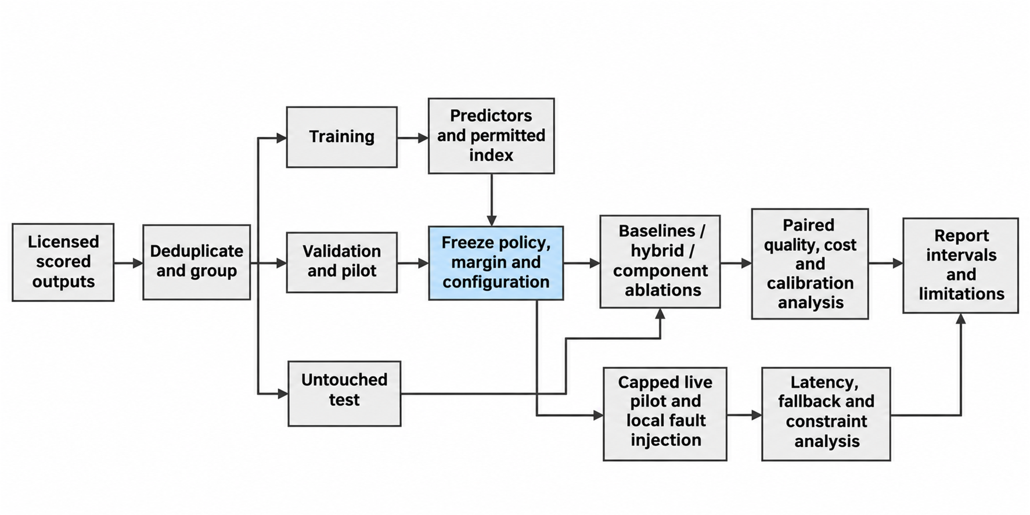
Figure 3.11: Experiment and evaluation pipeline.

3.10 Ethical Considerations
No formal ethical approval is sought for this study because it uses public benchmark data and synthetic or redacted requests and involves no human participants. This statement records the team’s position; it is not an approval certificate or an exemption granted by the university.
The experiments will use permitted public benchmark material, synthetic requests where suitable and redacted operational records. The team will avoid personal data, preserve anonymity, respect source and dataset rights and report findings honestly, without inventing results, selectively omitting them or presenting them as evidence of human review that did not happen. If people are later involved, informed consent, voluntary participation and anonymised responses will come before any collection, and the team will check the university’s process before the scope changes.
The use of generative AI tools is declared in full in the declaration at the front of this report and in the log in Appendix H, with tool, task, section and the way the output was checked. Team members will read the key cited papers themselves and correct any summary that proves wrong.

3.11 Risk Assessment
Table 3.11 lists the main risks with their likelihood (L) and impact (I), rated high (H), medium (M) or low (L), and a mitigation for each.
Table 3.11: Risk assessment
Risk | L | I | Mitigation
No aligned scored outputs for the chosen models | M | H | Check coverage in Phase 1; pick models from the aligned subset; record the limitation.
Local model does not fit laptop memory or runs too slowly | M | M | Profile both laptops in Sprint 2; use a smaller quantised model and treat it as a separate configuration.
Hosted API spending exceeds the budget | M | M | Hard spending cap enforced in the gateway; replay for most experiments.
Dataset licence blocks use or sharing | M | H | Clear licences in Appendix G before use; share only configurations and aggregate results.
Provider changes an API, price or availability during the project | H | M | Pin versions and record dates; keep adapters isolated.
Laptop thermal throttling distorts timing | H | M | Fixed power mode, repeated runs, recorded temperatures; report variability.
Hybrid shows no gain over simpler baselines | M | L | Report it as a valid finding; ablations and baselines are already planned.
Scope creep (extra dashboards, memory features) | M | M | Freeze requirements after Sprint 2; extras stay optional.
Team workload and exam periods delay sprints | H | M | Two-week sprints with slack before deadlines; named owners and backups; supervisor review.

3.12 Work Plan
Work follows two-week Scrum sprints from November 2026 to May 2027, with the report due in June 2027. Table 3.12 gives each sprint, its owners and its deliverable. Owners follow the roles proposed in the team’s task list; the roles will be confirmed with the supervisor, and the sixth member will be given tasks at the first sprint planning meeting. Evaluation and report writing overlap with implementation and do not wait for it. The Gantt chart and the record of supervisor meetings will be kept in Appendix F.
Table 3.12: Sprint plan
Sprint | Period | Owners | Deliverable
1. Requirements and protocol | Nov–Dec 2026 | Solomon, Wahida | Requirements, dataset coverage check, licence register, experiment protocol
2. Gateway core | Dec 2026–Jan 2027 | Waris, Maryam | API, validation, registry, database; laptop profiling
3. Adapters and baselines | Jan–Feb 2027 | Waris, Maryam, Kabiru | Hosted and local adapters; fixed, cheapest and rule-based policies; logging
4. Features | Feb 2027 | Solomon | Task classification, embeddings and k-NN index
5. Predictor and selector | Mar 2027 | Solomon, Waris | Suitability predictor, calibration, constrained selector, ablation configurations
6. Reliability | Mar–Apr 2027 | Waris, Maryam | Health tracker, circuit breaker, bounded fallback, accounting
7. Testing and deployment | Apr 2027 | Maryam, Kabiru, Wahida | Fault-injection tests, deployed gateway, operator view
8. Evaluation | Apr–May 2027 | Solomon, Maryam | Replay evaluation and capped live pilot
9. Analysis and report | May 2027 | All; Wahida leads documentation | Result tables, final report draft

3.13 Budget
Table 3.13 lists the expected costs in naira. The two laptops, open-source software and public datasets are already available at no cost. The amounts are the team’s estimates and will be confirmed with the supervisor; the hosted-call line is a hard cap enforced by the gateway itself.
Table 3.13: Estimated budget (naira)
Item | Quantity | Estimated cost (₦) | How it is met
Hosted model calls (capped pilot) | Up to US$20 at an assumed ₦1,500 per US$ | 30,000 | Team contribution; hard cap in the gateway
Internet data for downloads and API calls | 6 months | 60,000 | Team contribution
Printing and binding of the final report | 8 copies | 48,000 | Team contribution
Transport for supervision meetings and defence | Estimate | 30,000 | Team contribution
Two RTX 4070 laptops | 2 | 0 | Already owned by members
Open-source software and public datasets | Not applicable | 0 | Free
Contingency (10%) | Not applicable | 16,800 | Team contribution
Total |  | 184,800

3.14 Expected Outcomes
The project is expected to deliver the following, each linked to an objective of Section 1.3.
• A requirements specification, preliminary design and traceability matrix (Objective 1).
• A working, documented gateway with adapters, eligibility checks, constrained selection and logging (Objective 2).
• A suitability predictor with ablation results on held-out scored requests (Objective 3).
• A comparison of the constrained selector with simpler baselines on quality, cost and latency (Objective 4).
• A reliability mechanism with fault-injection results (Objective 5).
• A deployed gateway, a test and evaluation package, deployment instructions and the final report (Objective 6).
A conference or workshop paper may follow if the results are clear. The project does not promise a positive result: a simpler router that matches the hybrid is an acceptable and reportable finding.

3.15 Chapter Summary
This chapter chose Design Science Research for the study and Scrum with two-week sprints for the building work, and it set out how requirements will be gathered from documents, benchmark data and scenarios. It stated the requirements, a preliminary design with the routing algorithm, the data and the tools. Every objective has a method, a metric, a target and a baseline, and the data protocol keeps evaluated outcomes out of training and retrieval. The chapter closed with the ethical position, the risks, a sprint plan, an estimated budget in naira and the expected outcomes. Chapter Four will report the implementation and the measured evidence.

CHAPTER FOUR

IMPLEMENTATION, TESTING AND RESULTS
Open with a short paragraph describing the contents of the chapter. Report what was built and tested, and the evidence that each objective was met. Target length: 15 to 25 pages.

4.1 Development Environment
Table 4.1: Hardware and software requirements
Category | Development | Deployment / minimum for users
Processor | e.g., Intel Core i5, 2.4 GHz
Memory (RAM) | e.g., 8 GB
Operating system | e.g., Windows 11
Software / runtime | e.g., Node.js 20, PostgreSQL 16

4.2 Implementation of System Modules
For each main module, describe what was implemented, show a captioned screenshot of the key interface and, where useful, a short code snippet (no more than 15 lines) of the core logic. Refer to the requirement IDs implemented. Put the full source code in a repository and give the link in Appendix A.

4.3 Database Implementation
Show how the schema was implemented: tables created, relationships and key constraints, with screenshots or SQL/DDL excerpts.

4.4 Integration and Deployment
Describe how the components were integrated and how the system was deployed (hosting platform, URL, containers, version control, CI/CD).

4.5 System Testing

4.5.1 Testing Strategy
Summarise the levels and types of testing performed and the tools used (for example Jest, PyTest, Selenium, Postman, JMeter).

4.5.2 Unit and Integration Testing
Report the unit and integration tests performed and their results (number of tests, pass rate, coverage if measured).

4.5.3 Functional Testing
Present the test cases in a table and link each one to a functional requirement. The full set of test cases goes in Appendix D.
Table 4.2: Functional test cases
Test ID | Req. ID | Description | Input / steps | Expected result | Actual result | Status
TC-01 | FR-01 | e.g., Register with valid details | e.g., Valid name, email, password | e.g., Account created |  | e.g., Pass
TC-02 | FR-01 | e.g., Register with existing email |  | e.g., Error message shown

4.5.4 Non-Functional Testing
Report measured results against the targets in Table 3.2: performance and load (response times, throughput), security (for example, OWASP checks), compatibility (browsers and devices) and reliability.

4.5.5 Usability Evaluation and User Acceptance Testing
Describe the participants (number and profile; at least 20 is recommended), the tasks given and the instrument used (for example, the 10-item System Usability Scale). Report the results with descriptive statistics (mean, standard deviation) and interpret them against the benchmark of 68.

4.6 Results and Performance Evaluation
Present the results for each objective in turn, using tables and charts. For machine-learning projects, report accuracy, precision, recall, F1-score, a confusion matrix and cross-validation results, and compare against at least one baseline model. Report the results; interpret them in Section 4.7.

4.7 Discussion of Findings
Interpret the results. Explain what they mean, whether each objective was achieved, and how the results compare with the related works and existing systems in Chapter Two. Show how the project addresses the gap stated in Section 2.7.

4.8 Threats to Validity
Discuss factors that may limit the validity of the results (for example, small or unrepresentative test sample, synthetic data, test environment differing from real use) and how they were mitigated.

4.9 Chapter Summary
Summarise the implementation and the main results in one or two paragraphs.

CHAPTER FIVE

SUMMARY, CONCLUSION AND RECOMMENDATIONS
Open with a short paragraph describing the contents of the chapter. Do not introduce new results here. Target length: 3 to 6 pages.

5.1 Summary of the Project
Summarise the problem, the approach and the main results of the whole project in about one page.

5.2 Achievement of Objectives
Table 5.1: Achievement of objectives
Objective | How it was achieved | Evidence (section, table or figure)
Objective 1 |  | e.g., Section 3.5; Table 3.1
Objective 2
Objective 3
Objective 4

5.3 Contributions to Knowledge and Practice
Restate the contributions of the project, supported by the results.

5.4 Conclusion
State clearly what the project has shown, answering the research questions in Section 1.4. Keep it brief and evidence-based.

5.5 Limitations
Summarise the limitations of the final system and of the evaluation.

5.6 Recommendations
Give practical recommendations to specific stakeholders (users, organisations, the University, policy makers) based on the findings.

5.7 Future Work
Suggest specific extensions that future students or researchers could carry out.

REFERENCES
Aderaldo, C. M., & Mendonça, N. C. (2026). ResilienceBench-Operator: A Kubernetes extension for systematic evaluation of microservice resilience patterns. Journal of Software Engineering Research and Development, 14, 179–208. https://doi.org/10.5753/jserd.2026.6965
African Development Bank. (2026). African economic outlook 2026: Mobilizing Africa’s development financing at scale in a fragmented world. African Development Bank Group.
Aggarwal, P., Madaan, A., Anand, A., Potharaju, S. P., Mishra, S., Zhou, P., Gupta, A., Rajagopal, D., Kappaganthu, K., Yang, Y., Upadhyay, S., Faruqui, M., & Mausam. (2024). AutoMix: Automatically mixing language models. In A. Globerson, L. Mackey, D. Belgrave, A. Fan, U. Paquet, J. Tomczak, & C. Zhang (Eds.), Advances in Neural Information Processing Systems (Vol. 37). Curran Associates. https://doi.org/10.52202/079017-4164
Agrawal, A., Agarwal, A., Kedia, N., Mohan, J., Kundu, S., Kwatra, N., Ramjee, R., & Tumanov, A. (2024). Etalon: Holistic performance evaluation framework for LLM inference systems [Preprint]. arXiv. https://doi.org/10.48550/arXiv.2407.07000
Chen, L., Zaharia, M., & Zou, J. (2024). FrugalGPT: How to use large language models while reducing cost and improving performance. Transactions on Machine Learning Research. https://openreview.net/forum?id=cSimKw5p6R
Chen, S., Jia, Z., Khan, S., Krishnamurthy, A., & Gibbons, P. B. (2025). SLOs-Serve: Optimized serving of multi-SLO LLMs [Preprint]. arXiv. https://doi.org/10.48550/arXiv.2504.08784
Chen, S., Jiang, W., Lin, B., Kwok, J. T., & Zhang, Y. (2024). RouterDC: Query-based router by dual contrastive learning for assembling large language models. In A. Globerson, L. Mackey, D. Belgrave, A. Fan, U. Paquet, J. Tomczak, & C. Zhang (Eds.), Advances in Neural Information Processing Systems (Vol. 37). Curran Associates. https://doi.org/10.52202/079017-2120
Da, W., & Kalyvianaki, E. (2026). RouteBalance: Fused model routing and load balancing for heterogeneous LLM serving [Preprint]. arXiv. https://doi.org/10.48550/arXiv.2606.17949
Dekoninck, J., Baader, M., & Vechev, M. (2025). A unified approach to routing and cascading for LLMs. In Proceedings of the 42nd International Conference on Machine Learning (Vol. 267, pp. 12987–13010). PMLR. https://proceedings.mlr.press/v267/dekoninck25a.html
Ding, D., Mallick, A., Wang, C., Sim, R., Mukherjee, S., Rühle, V., Lakshmanan, L. V. S., & Awadallah, A. H. (2024). Hybrid LLM: Cost-efficient and quality-aware query routing. In Proceedings of the Twelfth International Conference on Learning Representations (ICLR 2024). https://openreview.net/forum?id=02f3mUtqnM
Ding, D., Mallick, A., Zhang, S., Wang, C., Madrigal, D., Garcia, M. D. C. H., Xia, M., Lakshmanan, L. V. S., Wu, Q., & Rühle, V. (2025). BEST-Route: Adaptive LLM routing with test-time optimal compute. In Proceedings of the 42nd International Conference on Machine Learning (Vol. 267, pp. 13870–13884). PMLR. https://proceedings.mlr.press/v267/ding25d.html
Federal Ministry of Communications, Innovation and Digital Economy. (2025). National artificial intelligence strategy. https://ncair.nitda.gov.ng/wp-content/uploads/2025/09/National-Artificial-Intelligence-Strategy-19092025.pdf
Federal Republic of Nigeria. (2023). Nigeria Data Protection Act, 2023 (Act No. 37; Official Gazette No. 119, Vol. 110, pp. A719–A758). The Federal Government Printer. https://ngfrepository.org.ng:8443/jspui/handle/123456789/7548
Goel, K., Mohan, J., Kwatra, N., Anupindi, R. S., & Ramjee, R. (2026). QoServe: Breaking the silos of LLM inference serving. In Proceedings of the 31st ACM International Conference on Architectural Support for Programming Languages and Operating Systems, Volume 2 (pp. 1492–1507). Association for Computing Machinery. https://doi.org/10.1145/3779212.3790206
Griggs, T., Liu, X., Yu, J., Kim, D., Chiang, W.-L., Cheung, A., & Stoica, I. (2024). Mélange: Cost efficient large language model serving by exploiting GPU heterogeneity [Preprint]. arXiv. https://doi.org/10.48550/arXiv.2404.14527
Gujarati, A., Karimi, R., Alzayat, S., Hao, W., Kaufmann, A., Vigfusson, Y., & Mace, J. (2020). Serving DNNs like Clockwork: Performance predictability from the bottom up. In Proceedings of the 14th USENIX Symposium on Operating Systems Design and Implementation (OSDI 20) (pp. 443–462). USENIX Association. https://www.usenix.org/conference/osdi20/presentation/gujarati
Gupta, N., Narasimhan, H., Jitkrittum, W., Rawat, A. S., Menon, A. K., & Kumar, S. (2024). Language model cascades: Token-level uncertainty and beyond. In The Twelfth International Conference on Learning Representations. https://openreview.net/forum?id=KgaBScZ4VI
Hevner, A. R., March, S. T., Park, J., & Ram, S. (2004). Design science in information systems research. MIS Quarterly, 28(1), 75–105. https://doi.org/10.2307/25148625
Hu, Q. J., Bieker, J., Li, X., Jiang, N., Keigwin, B., Ranganath, G., Keutzer, K., & Upadhyay, S. K. (2024). RouterBench: A benchmark for multi-LLM routing system [Preprint]. arXiv. https://doi.org/10.48550/arXiv.2403.12031
Jiang, D., Ren, X., & Lin, B. Y. (2023). LLM-Blender: Ensembling large language models with pairwise ranking and generative fusion. In Proceedings of the 61st Annual Meeting of the Association for Computational Linguistics (Volume 1: Long Papers) (pp. 14165–14178). Association for Computational Linguistics. https://doi.org/10.18653/v1/2023.acl-long.792
Kwon, W., Li, Z., Zhuang, S., Sheng, Y., Zheng, L., Yu, C. H., Gonzalez, J. E., Zhang, H., & Stoica, I. (2023). Efficient memory management for large language model serving with PagedAttention. In Proceedings of the 29th Symposium on Operating Systems Principles (pp. 611–626). Association for Computing Machinery. https://doi.org/10.1145/3600006.3613165
Li, H., Zhang, Y., Guo, Z., Wang, C., Tang, S., Zhang, Q., Chen, Y., Qi, B., Ye, P., Bai, L., Wang, Z., & Hu, S. (2026). LLMRouterBench: A massive benchmark and unified framework for LLM routing. In Findings of the Association for Computational Linguistics: ACL 2026 (pp. 37733–37754). Association for Computational Linguistics. https://doi.org/10.18653/v1/2026.findings-acl.1881
LiteLLM. (n.d.). Router: Load balancing and routing. Retrieved 31 October 2026, from https://docs.litellm.ai/docs/routing
Lu, K., Yuan, H., Lin, R., Lin, J., Yuan, Z., Zhou, C., & Zhou, J. (2024). Routing to the expert: Efficient reward-guided ensemble of large language models. In Proceedings of the 2024 Conference of the North American Chapter of the Association for Computational Linguistics: Human Language Technologies (Volume 1: Long Papers) (pp. 1964–1974). Association for Computational Linguistics. https://doi.org/10.18653/v1/2024.naacl-long.109
Miao, X., Shi, C., Duan, J., Xi, X., Lin, D., Cui, B., & Jia, Z. (2024). SpotServe: Serving generative large language models on preemptible instances. In Proceedings of the 29th ACM International Conference on Architectural Support for Programming Languages and Operating Systems, Volume 2 (pp. 1112–1127). ACM. https://doi.org/10.1145/3620665.3640411
Mohammadshahi, A., Shaikh, A. R., & Yazdani, M. (2024). Routoo: Learning to route to large language models effectively [Preprint]. arXiv. https://doi.org/10.48550/arXiv.2401.13979
Ong, I., Almahairi, A., Wu, V., Chiang, W.-L., Wu, T., Gonzalez, J. E., Kadous, M. W., & Stoica, I. (2025). RouteLLM: Learning to route LLMs from preference data. In Proceedings of the Thirteenth International Conference on Learning Representations (ICLR 2025). https://proceedings.iclr.cc/paper_files/paper/2025/hash/5503a7c69d48a2f86fc00b3dc09de686-Abstract-Conference.html
OpenRouter. (n.d.). Auto router. Retrieved 31 October 2026, from https://openrouter.ai/docs/guides/routing/routers/auto-router
Pandey, V., & Singh, G. (2026a). ContinuityBench: A benchmark and systems study of stateful failover in multi-provider LLM routing [Preprint]. arXiv. https://doi.org/10.48550/arXiv.2607.15899
Pandey, V., & Singh, G. (2026b). FailureAtlas: A taxonomy of failure modes in multi-provider LLM serving infrastructure [Preprint]. arXiv. https://doi.org/10.48550/arXiv.2607.17525
Peffers, K., Tuunanen, T., Rothenberger, M. A., & Chatterjee, S. (2007). A design science research methodology for information systems research. Journal of Management Information Systems, 24(3), 45–77. https://doi.org/10.2753/MIS0742-1222240302
Portkey. (n.d.). Fallbacks. Retrieved 31 October 2026, from https://portkey.ai/docs/product/ai-gateway/fallbacks
Romero, F., Li, Q., Yadwadkar, N. J., & Kozyrakis, C. (2021). INFaaS: Automated model-less inference serving. In Proceedings of the 2021 USENIX Annual Technical Conference (pp. 397–411). USENIX Association. https://www.usenix.org/conference/atc21/presentation/romero
Šakota, M., Peyrard, M., & West, R. (2024). Fly-swat or cannon? Cost-effective language model choice via meta-modeling. In Proceedings of the 17th ACM International Conference on Web Search and Data Mining (pp. 606–615). Association for Computing Machinery. https://doi.org/10.1145/3616855.3635825
Shirkavand, R., Gao, S., Yu, P., & Huang, H. (2025). Cost-aware contrastive routing for LLMs. Advances in Neural Information Processing Systems, 38. https://doi.org/10.52202/085713-5202
Shnitzer, T., Ou, A., Silva, M., Soule, K., Sun, Y., Solomon, J., Thompson, N., & Yurochkin, M. (2023). Large language model routing with benchmark datasets (arXiv:2309.15789). arXiv. https://doi.org/10.48550/arXiv.2309.15789
Stanford Institute for Human-Centered Artificial Intelligence. (2025). AI Index 2025: State of AI in 10 charts. https://hai.stanford.edu/news/ai-index-2025-state-of-ai-in-10-charts
Strati, F., McAllister, S., Phanishayee, A., Tarnawski, J., & Klimovic, A. (2024). DéjàVu: KV-cache streaming for fast, fault-tolerant generative LLM serving. In Proceedings of the 41st International Conference on Machine Learning (Vol. 235, pp. 46745–46771). PMLR. https://proceedings.mlr.press/v235/strati24a.html
Toniolo, A. R., Thorstenson, R., & Dinesh, A. (2026). GORGO: Online tuning for cross-region network-aware LLM serving [Preprint]. arXiv. https://doi.org/10.48550/arXiv.2602.11688
Varangot-Reille, C., Bouvard, C., & Gourru, A. (2026). Generalising LLM routing using past performance retrieval: A few-shot router is sufficient. In Proceedings of the 19th Conference of the European Chapter of the Association for Computational Linguistics (Volume 4: Student Research Workshop) (pp. 304–319). Association for Computational Linguistics. https://doi.org/10.18653/v1/2026.eacl-srw.22
Xiong, M., Hu, Z., Lu, X., Li, Y., Fu, J., He, J., & Hooi, B. (2024). Can LLMs express their uncertainty? An empirical evaluation of confidence elicitation in LLMs. The Twelfth International Conference on Learning Representations. https://openreview.net/forum?id=gjeQKFxFpZ
Zhong, Y., Liu, S., Chen, J., Hu, J., Zhu, Y., Liu, X., Jin, X., & Zhang, H. (2024). DistServe: Disaggregating prefill and decoding for goodput-optimized large language model serving. In Proceedings of the 18th USENIX Symposium on Operating Systems Design and Implementation (OSDI 24) (pp. 193–210). USENIX Association. https://www.usenix.org/conference/osdi24/presentation/zhong-yinmin
Zhuang, R., Wu, T., Wen, Z., Li, A., Jiao, J., & Ramchandran, K. (2025). EmbedLLM: Learning compact representations of large language models. The Thirteenth International Conference on Learning Representations. https://proceedings.iclr.cc/paper_files/paper/2025/hash/bf5e4b85d203481d6e37bd32d9600162-Abstract-Conference.html

APPENDICES
Number appendices with letters and refer to each one in the text.
Appendix A: Source code repository link and key code listings
Appendix B: User manual and installation guide
Appendix C: Questionnaires, interview guides and consent forms
Appendix D: Full test cases and test results
Appendix E: Similarity (plagiarism) report summary
Appendix F: Project schedule (Gantt chart) and record of group meetings with the supervisor
Appendix G: Dataset and licence register
Appendix H: Generative AI use log and figure prompts
Appendix I: Experiment protocol and analysis plan

